INSPECTION & SPECIFICATION SERVICES CC.
ISS
CONTROLLED ENGINEERING INSPECTION REPORT
Combined-Product Spillage
Inspection and Engineering Assessment Report
South32 Wessels Mine · Surface and Underground Conveyor / Process Areas
INTEGRATED CONTROLLED DRAFT · REVISION 0.6 · NOT FOR ISSUE

Client | South32
Mine / site | Wessels Mine
Area / system | Combined-product handling and processing systems - selected surface and underground sections
Report number | S32WPPSR-01
Revision | 0.6 - Integrated Controlled Draft
Issue date | 28 August 2026
Inspection date / range | [INSPECTION DATE / DATE RANGE]
Prepared by | Inspection & Specification Services cc.
Inspection & Specification Services cc.
Reg. No. 1990/020258/23
24 Jonkershoek Street, Vaalpark, 1947
iss@inspecserv.co.za

Document Control and Metadata
Table 1 - Document control and report metadata
Field | Value
Report title | Combined-Product Spillage Inspection and Engineering Assessment Report
Report number | S32WPPSR-01
Revision | 0.6
Issue status | Integrated Controlled Draft / Not for Issue
Issue date | 28 August 2026
Client | South32
Mine / site | Wessels Mine
System | Combined-product handling and processing systems
Primary drafting source | Context/Running_Report_Contextual_Spillage_NotesV4.3.md + Stage-A Gap Register + current evidence controls
Evidence register | evidence_index_CURRENT.md + active evidence overlays — 196 controlled media / 79 E / 40 S / 77 A
Template lineage | Adapted from ISS Sheave Inspection Report Master Template v2.1 structure

Prepared, Reviewed and Approved
Table 2 - Document authorization record
Role | Name | Title / Discipline | Date | Signature
Prepared by | [PREPARED BY] | [TITLE] | [DATE]
Reviewed by | [REVIEWED BY] | [TITLE] | [DATE]
Approved by | [APPROVED BY] | [TITLE] | [DATE]

Revision History
Table 3 - Revision history
Revision | Date | Change description | Prepared by | Approved by
0.1 | [DATE] | Initial spillage-report working base adapted from ISS sheave-report structure using consolidated Contextual Notes V3.7 and completed evidence review. | [NAME] | [NAME]
0.2 | 25 Aug 2026 | Phase 6 assembly draft: accepted narrative architecture + evidence hierarchy + CV09 holistic evidence grammar integrated into one full report structure. | ISS | Draft review
0.3 | 25 Aug 2026 | Phase 7 compilation draft: refined Parts I-XII, mature action programme, verification register, technical appendices and current conceptual engineering figures compiled into the approved V0.2 report architecture. | ISS | Draft review
0.4 | 25 Aug 2026 | Language-harmonised revision: V0.3 engineering substance retained while reader-facing narrative was aligned to the accepted V0.2 softer formal-engineering style under Context V3.12. | ISS | Draft review
0.5 | 25 Aug 2026 | Global terminology refinement: reader-facing uses of “envelope” were replaced with direct physical terms such as material-handling path, carrying path, process stream/process path and installation space. “Envelope” is retained only where it describes a defined geometric or operating range, such as belt tracking or normal operating envelope. | ISS | Draft review
0.6 | 28 Aug 2026 | Stage-B integrated controlled revision: V0.5 reconciled against source-reconciled Context V4.3, Stage-A gap register, current evidence overlays and locked functional engineering / operational-control concepts. Superseded evidence and conceptual interpretations removed from active report use. | ISS | Draft review

Controlled Distribution
Table 4 - Controlled distribution list
Recipient / role | Organisation | Purpose | Controlled copy
[CLIENT CONTACT] | South32 | Review / action tracking | [YES / NO]
[ISS FILE] | ISS | Controlled project record | Yes
V0.6 STAGE-B INTEGRATION CONTROL NOTE
This revision consolidates the source-reconciled engineering context and the later accepted solution/evidence closures into the V0.5 report architecture. It restores technical detail where that materially improves understanding and incorporates the current CV09, W10, Sample Conveyor, U4/L3, Screens, L1, trip/restart and housekeeping control positions.
This file remains NOT FOR ISSUE and is not content freeze. Evidence/body/appendix allocation, final conceptual-figure placement, outstanding site measurements and verification, responsible-engineer/OEM/competent-authority review, publication formatting and formal issue authorisation remain open. The V0.2-derived explanatory narrative style and V0.5 direct physical-path terminology remain binding.

Table of Contents
1 Executive Summary
2 Purpose and Objectives
3 Scope of the Audit
4 Methodology, Evidence Basis and Limitations
5 The Material Journey
6 Central Audit Principle — Spillage Location Is Not Always Cause Location
7 The Overall Spillage Picture
8 Fines Are Being Lost Progressively Through the Conveyor Ecosystem
9 Why Belt Cleaning Alone Is Not the Full Control Function
10 Cleaner / Fines-Control Philosophy and CV09 Pilot
11 The Containment Problem Is Not Limited to Fines
12 W10 — Coarse Product Loss in a Confined Tunnel
13 Sample Conveyors — Product Size, Feed and Limited Carrying Width
14 Belt Tracking as a Material-Containment Requirement
15 U4 Tripper Car — Strong Local Cause-and-Effect Example
16 L3 — Alignment Concern Without Proven Solid-Product Causal Chain
17 Water as a Material-Transport and Deterioration Mechanism
18 Screens — Confirmed Water Escape / Separate Structural Story
19 L1 — Spillage, Historical Belt Contact and Structural Deterioration
20 Trips, Restart and Manual Product Removal
21 Housekeeping — Necessary but Not the Primary Solution
22 Consolidated Engineering Interpretation
23 Engineering Control Philosophy — Keep the Combined Product Inside the Process
24 Programme Structure and Implementation Principle
25 Priority 2 — Correct or Verify Local Material-Loss / Alignment Mechanisms
26 Priority 3 — Water Containment and Structural Actions
27 Priority 4 — Extend Proven Controls Where Applicable
28 Priority 5 — Operational and Housekeeping Governance
29 Conclusion
30 Technical Review and Report Issue Sign-off
Page numbers remain provisional in this V0.6 integrated controlled draft. The automatic Table of Contents, List of Figures, List of Tables and final cross-references will be refreshed during the publication-formatting pass.

List of Figures
Figure numbering and final captions remain provisional. Canonical evidence IDs and controlled conceptual-drawing IDs are retained so the final figure register can be completed without losing traceability.

List of Tables
Table numbering and final cross-references will be refreshed during the publication-formatting pass after V0.6 content and evidence review.

PART I — WHY THE AUDIT WAS UNDERTAKEN

1 Executive Summary
Spillage was observed at multiple locations across the Wessels material-handling system, from the underground crusher and conveyor route through the surface screening and loading-station areas. The audit was undertaken to determine whether these deposits were isolated housekeeping problems or evidence of broader failures to keep combined product and process water within their intended handling and process paths.
The evidence does not support one universal spillage mechanism. The strongest recurring system pattern is fines/carryback, with repeated accumulation along return-side and downstream conveyor areas. Other important local mechanisms include coarse or mixed product leaving the usable carrying area, belt tracking/alignment concerns, loading and product-size pressure on narrow Sample Conveyors, active process-water escape at the Screens, structural deterioration, and intermittent event-driven product removal associated with trips or restart preparation.
A central finding is that the location where material accumulates is not necessarily the location where the initiating failure occurs. Residual fines can remain on the return belt after discharge and detach progressively downstream; rollers/idlers can dislodge additional adhered material; water can mobilise fines away from an original escape point; mistracking can reduce carrying margin before product is lost; and trip/restart clearing can create a temporary deposit that is operationally different from chronic spillage.
Taken together, the evidence indicates that increased housekeeping alone will not provide a sustainable long-term solution. Housekeeping remains necessary for access, recovery and consequence control, but recurring deposits require the underlying source mechanism or primary contributor to be addressed where it can be established.
AUDIT TAKEAWAY | The mine has a material-containment problem with several mechanisms, not simply a housekeeping problem or a collection of unrelated scraper defects.
The higher-order engineering objective is therefore to keep combined product — fines and coarse/lump ore — within the intended material-handling path throughout transit and to retain process water within the screening and processing systems where it is intended to remain. The physical control should match the actual mechanism and local geometry rather than impose one universal hardware solution.
The recommended programme combines system-level source control with targeted local actions. CV09 remains the preferred pilot for a pulley-supported cleaner system located inside the head/discharge chute so removed fines remain in the existing discharge flow. W10 requires belt-edge side skirting/spill sealing as the residual lateral-containment concept after primary contributors are checked. Sample Conveyors 2 and 3 require feed/product-size/loading/tracking verification before final containment is detailed. U4 and L3 require location-specific alignment/tracking verification; the Screens require separate water-source and structural workstreams; L1 requires structural and belt-clearance assessment; and trip/restart and housekeeping controls require area-specific operational confirmation. Functional success should ultimately be demonstrated under representative operation rather than inferred from work completion or a temporarily clean area.

2 Purpose and Objectives
The purpose of the audit is to identify where combined product or process water is escaping its intended handling path, determine the mechanisms and contributing conditions associated with those losses where the available evidence allows, distinguish recurring system mechanisms from local asset-specific conditions, and define practical engineering, maintenance and operational actions that can reduce recurrence.
- Identify the material types and locations at which visible losses occur.
- Determine the immediate mechanism and contributing condition where the available evidence supports that conclusion.
- Distinguish visually proven conditions from inspector-recorded observations, engineering interpretation and unresolved verification items.
- Develop practical source-control, containment, maintenance, alignment, structural and operational actions.
- Provide a controlled evidence record that allows engineering and maintenance personnel to trace each major conclusion back to the inspection evidence.
The audit is qualitative and mechanism-focused. It does not attempt to infer total lost tonnage or volume from photographs, and unverified numerical tolerances, feed rates, structural capacities or OEM limits are not introduced as report facts. Visible extent is used to describe the inspected condition, while values that were not measured remain items for later measurement, design development or competent assessment.

3 Scope of the Audit
The inspected locations form one connected material-handling route and are treated as an ecosystem rather than as an unrelated list of assets.
Process area | Included assets / groups
Underground — Central Block | Underground Crusher; UC05 / UC04 / UC03 / UC02 / UC01 continuous conveyor system
Underground — Secondary Plant | U3 Conveyor; U4 Tripper Car
Underground — Silos / Feeders | U5A Conveyor; U5B Conveyor
Surface — Screening / Transfer | W10; CV01; CV02; CV03; CV04; CV06; CV09; CV14; CV15; Screens / screen chutes
Surface — Loading Station | L1; L2; L3; L4; Sample Conveyors 1, 2 and 3
CV05, CV07, CV08, CV10, CV11, CV12 and CV13 are outside the integrated scope of this report. The evidence record remains limited to the 23 controlled inspection groups represented in the final evidence matrix.

4 Methodology, Evidence Basis and Limitations
The assessment combines site inspection observations, still photographs, inspection videos, completed questionnaires, the source-reconciled Context V4.3, controlled visual-review records and the current evidence-index/overlay controls. The current active inspection-media population is 196 items: 188 photographs and 8 videos, classified for report-development priority as 79 Essential body (E), 40 Supporting/story (S) and 77 Appendix/reference (A). Each item retains its canonical ID. LoadoutStationSample3-REF-013 is withdrawn from active use because it was confirmed to belong to another conveyor/belt and could not be reliably reassigned.
Evidence / statement type | Meaning in this report
Direct observation | Condition recorded directly during the inspection by the inspector.
Visual evidence-supported | Condition materially demonstrated by supplied photographs or video.
Source-recorded information | Operating, maintenance or historical information retained from inspection records/questionnaires.
Engineering interpretation / hypothesis | Reasoned explanation consistent with the observed condition but not fully proven by the available evidence.
Accepted functional remedial concept | Audit-level functional direction accepted for report development; site measurement, detailed design and implementation verification may remain open.
Unresolved / requires verification | Condition or magnitude that cannot be responsibly closed from the present evidence.
Detailed-design / competent-authority responsibility | OEM, responsible-engineer, structural authority or South32 governance detail that lies beyond the evidence-supported audit concept.
The inspection was performed around operating industrial equipment and access was therefore limited at some points. Where belt geometry, offset magnitude, cleaner contact/wear travel, feed quantity, remaining structural capacity, chute dimensions, internal screen-water source or design limits were not measured, the report deliberately carries those items forward for verification, detailed design or competent assessment rather than inferring a value. This applies particularly to the Sample Conveyor tracking conditions, U4 and L3 alignment, the internal Screens water-escape mechanism, Screens structural capacity and the L1 historical belt-contact/structural conditions.
PART II — UNDERSTANDING THE MATERIAL-HANDLING SYSTEM

5 The Material Journey
The material handled by the inspected system is combined product comprising lump/coarse ore together with fines. Fines are already present in the product stream and additional fines are generated through crushing and subsequent handling. Their presence is therefore not itself a defect; the audit concern begins when product or process water leaves its intended material-handling or process path before reaching the stage designed to receive or control it.
From the underground crusher onward, the conveyor system is intended to transport combined product through successive transfer and processing stages while retaining it within the designed material path. Residual carryback should be removed at appropriate discharge locations and kept inside the process; process water should remain within the screening/washing route; and material deliberately removed during unavoidable operating interventions should remain under controlled temporary handling and be recovered through an approved process route.
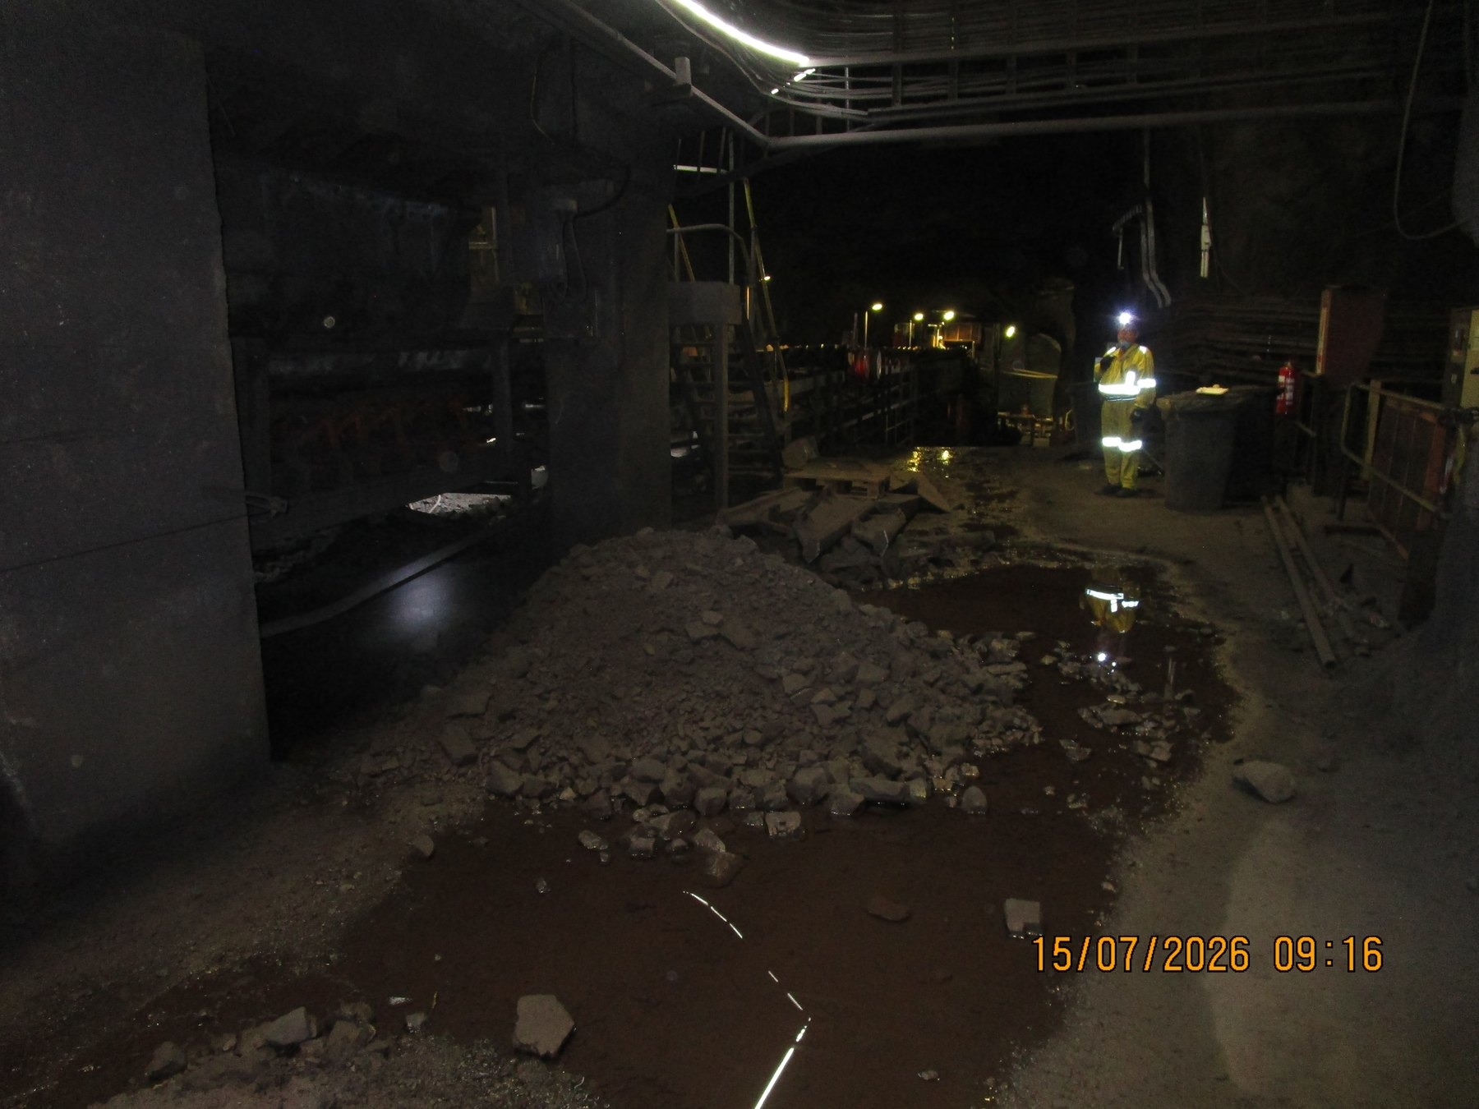  UGCrusher-REF-001 — mixed lump/fines accumulation at the underground start of the inspected conveyor ecosystem. | 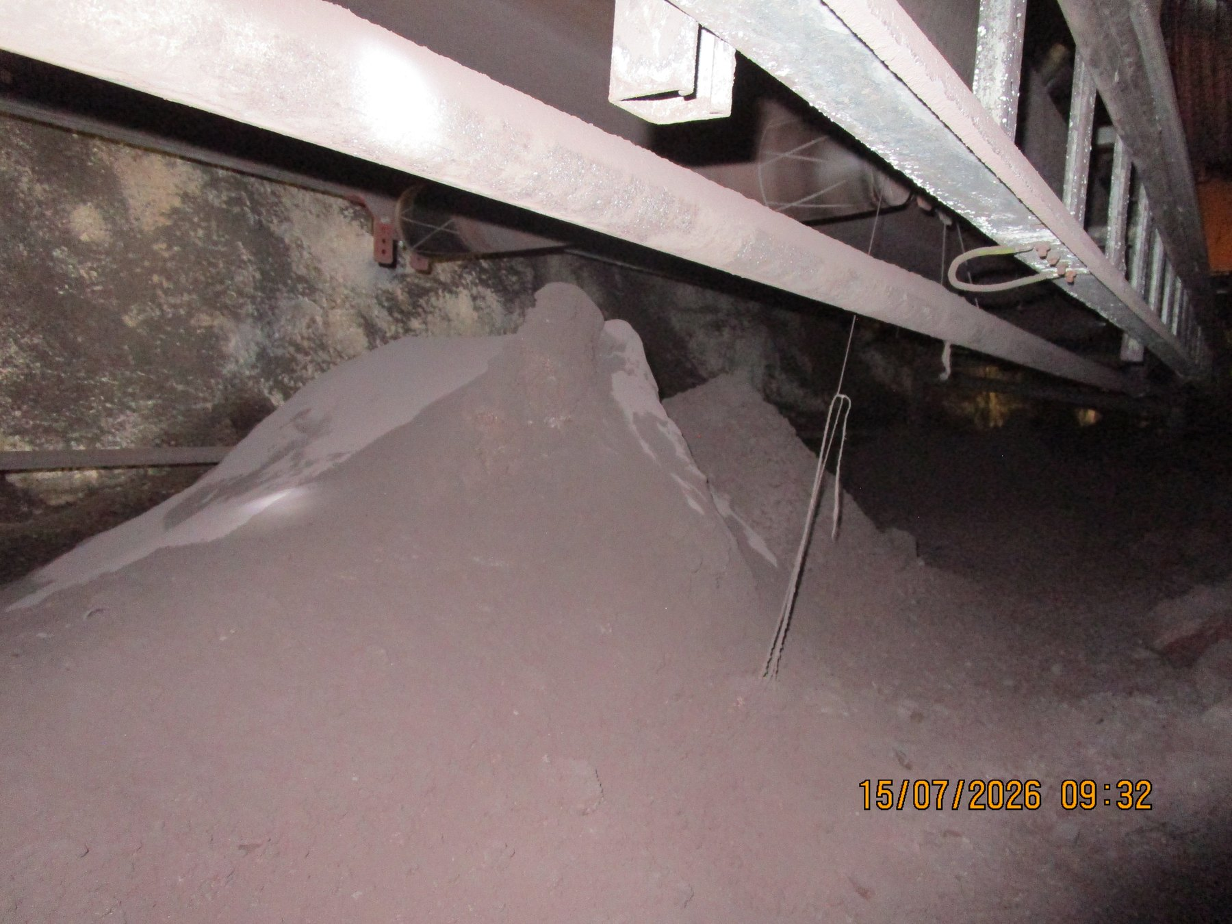  UGUC05_04_03_02_01-REF-006 — severe local accumulation along the continuous underground conveyor route.
READER TAKEAWAY | The report concerns loss of process containment during transport — not the mere presence of fines, lump ore or process water within the material-handling system.

6 Central Audit Principle — Spillage Location Is Not Always Cause Location
Visible spillage should not automatically be interpreted as a local equipment failure at the point where the material is found. A deposit may be the final consequence of an initiating condition that is upstream or functionally separate from the deposit location. For this reason, the assessment considers the observed deposit, the material type, the immediate mechanism, possible contributing conditions and the most appropriate control in sequence. Where the initiating cause cannot be established from the available evidence, the report leaves that point open for further verification rather than assigning an unsupported cause.
1. Fines/carryback can remain on the return belt after intended discharge and detach progressively as the belt flexes over downstream rollers.
2. Process or cleaning water can mobilise fines and transport contamination away from the original escape point.
3. Belt mistracking can reduce usable carrying margin before coarse/mixed product is lost at a later location.
4. Trip/restart clearing can place product beside a conveyor even when the initiating trip, blockage or intervention occurred elsewhere.
CAUSE / EFFECT SEQUENCE | Observed deposit → material type → immediate mechanism → contributing condition → initiating cause → consequence → control
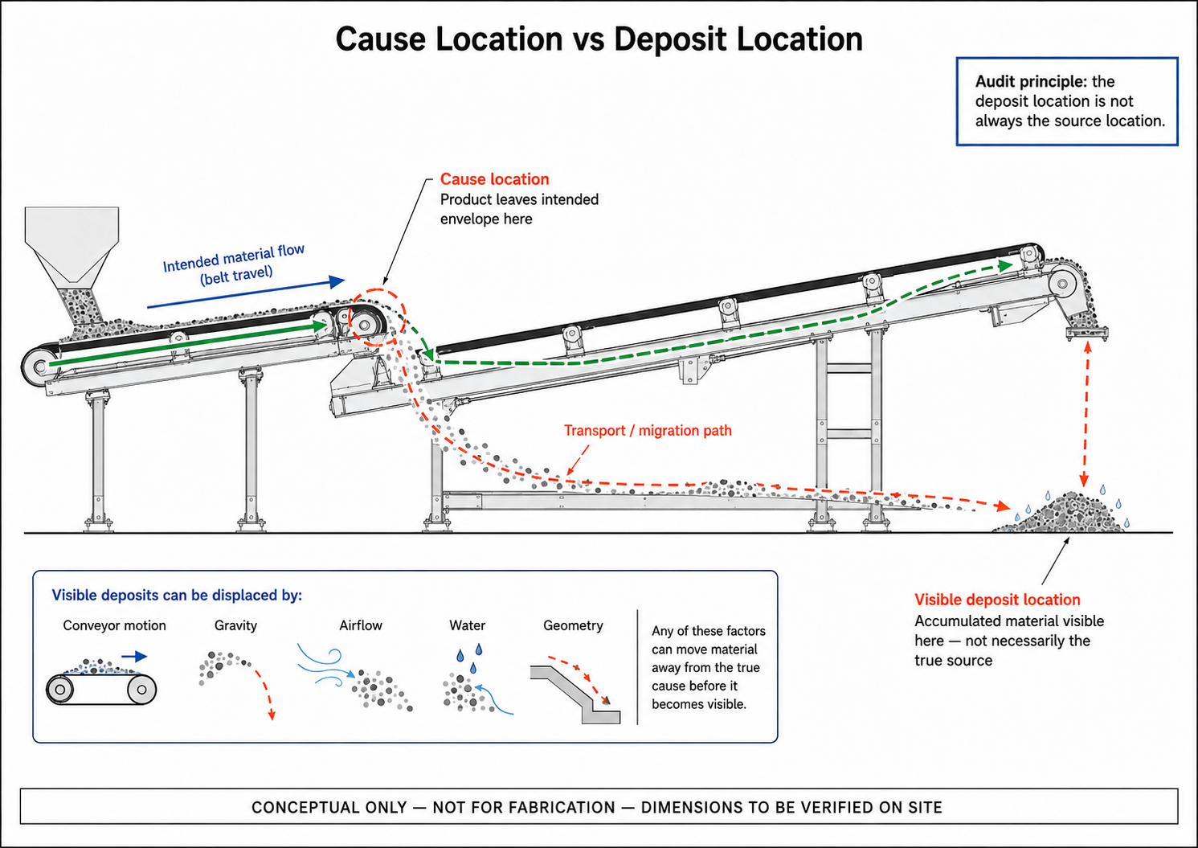
CTD-004 — Cause Location vs Deposit Location. Conceptual explanatory figure; not inspection evidence.
PART III — WHAT THE AUDIT FOUND

7 The Overall Spillage Picture
The evidence resolves into three recurring material-loss families and one event-driven operating mechanism: fines/carryback; coarse or mixed-product loss during transit; water-related escape, wet fines and slurry; and material removed during trip/restart or other operating interventions. These mechanisms can overlap at individual assets, but they do not all require the same physical control.
Mechanism family | Typical evidence / significance |  | Control direction
Fines / carryback | Recurring deposits along return-side and downstream conveyor areas; cleaner condition and containment are recurring themes. |  | Improve cleaning function and retain removed fines inside the process.
Coarse / mixed product transit loss | Product outside the intended carrying path at W10, Sample Conveyors and other local positions. |  | Feed/trajectory, tracking and location-specific containment.
Water / wet fines / slurry | Wet deposits and confirmed active screen water escape. |  | Retain process water; identify local escape mechanism; manage secondary structural consequences.
Trip / restart unloading | Source-recorded manual clearing after trips/blockages. |  | Confirm controlled temporary handling, approved recovery/reintroduction and restart governance; distinguish event-driven deposits from chronic source-generated spillage.
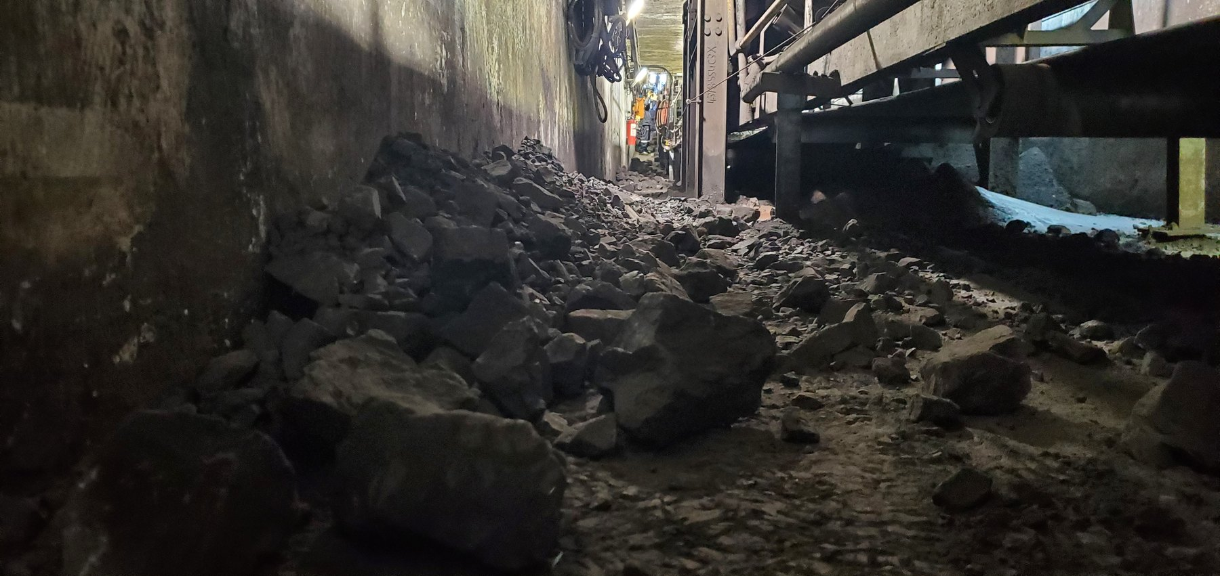  W10-REF-002 — coarse/mixed product occupying restricted tunnel access. |  | 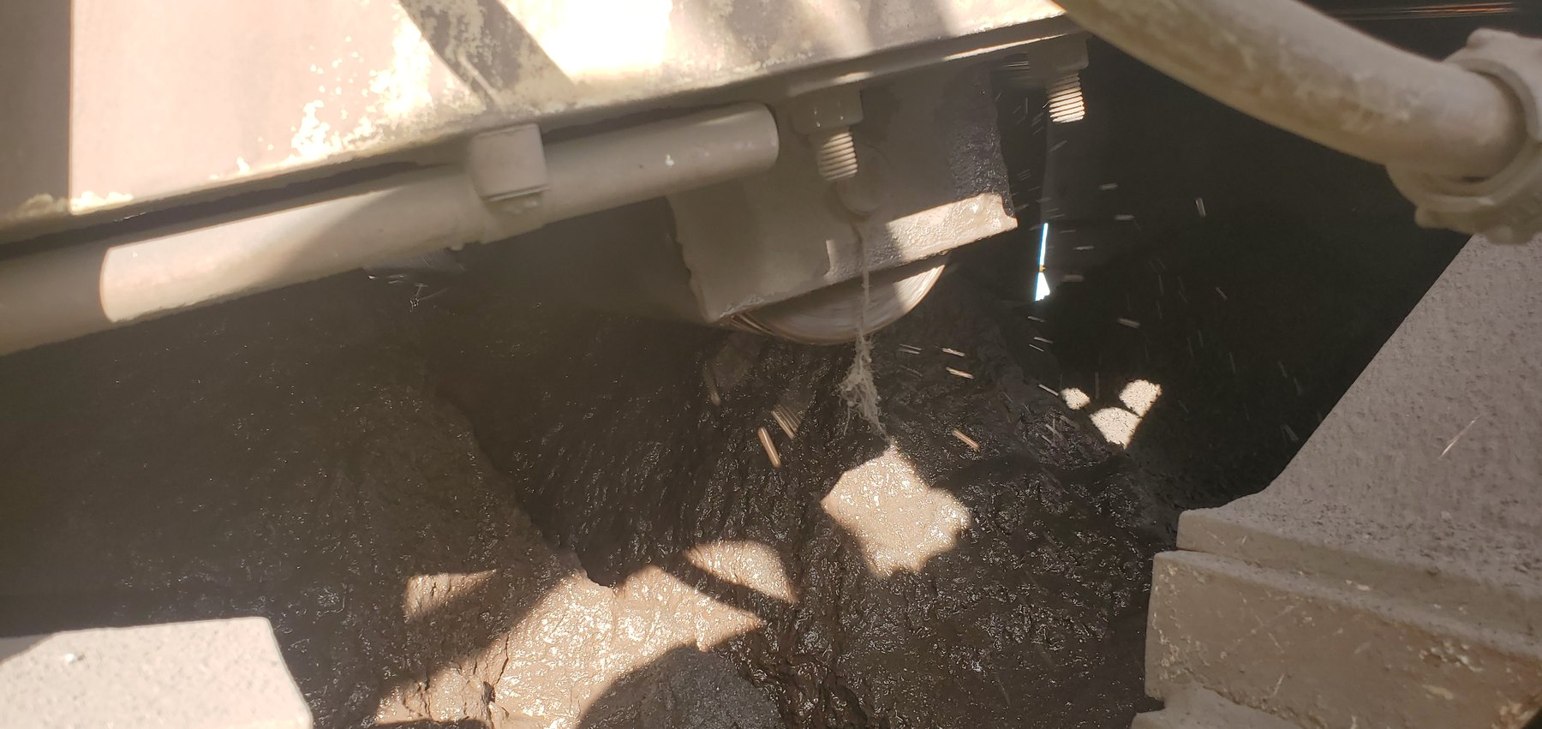  CV04-REF-002 — saturated wet-fines/slurry condition.
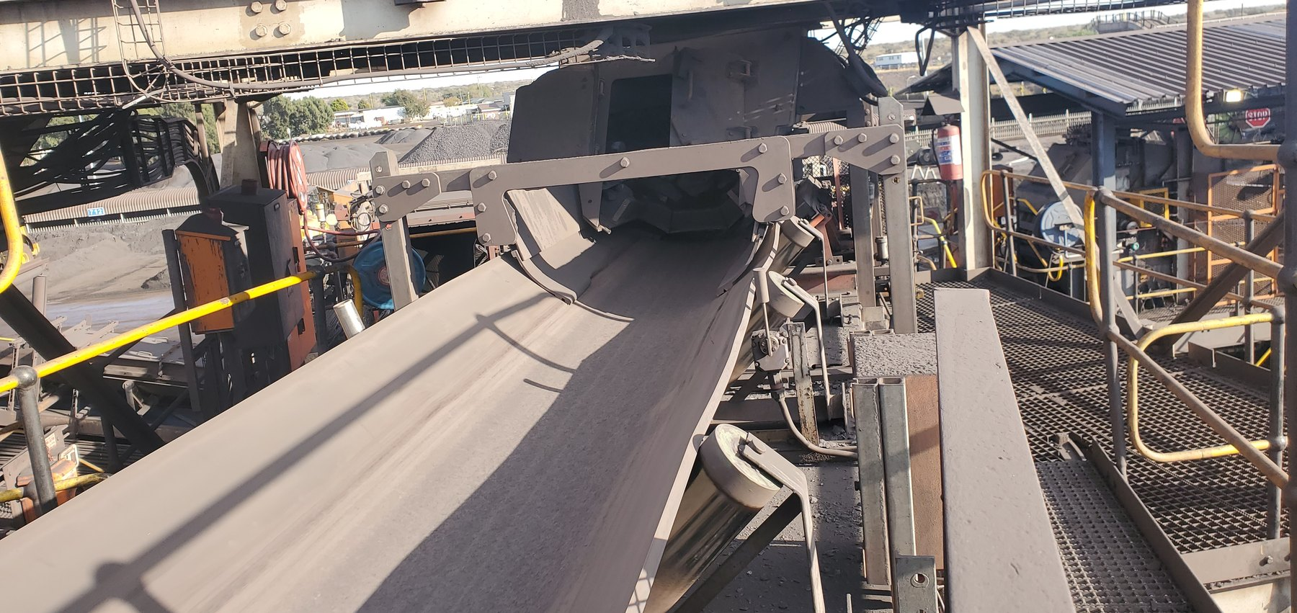  CV03-REF-002 — clean-condition comparator demonstrating that not every inspected conveyor was a significant spillage location. |  | 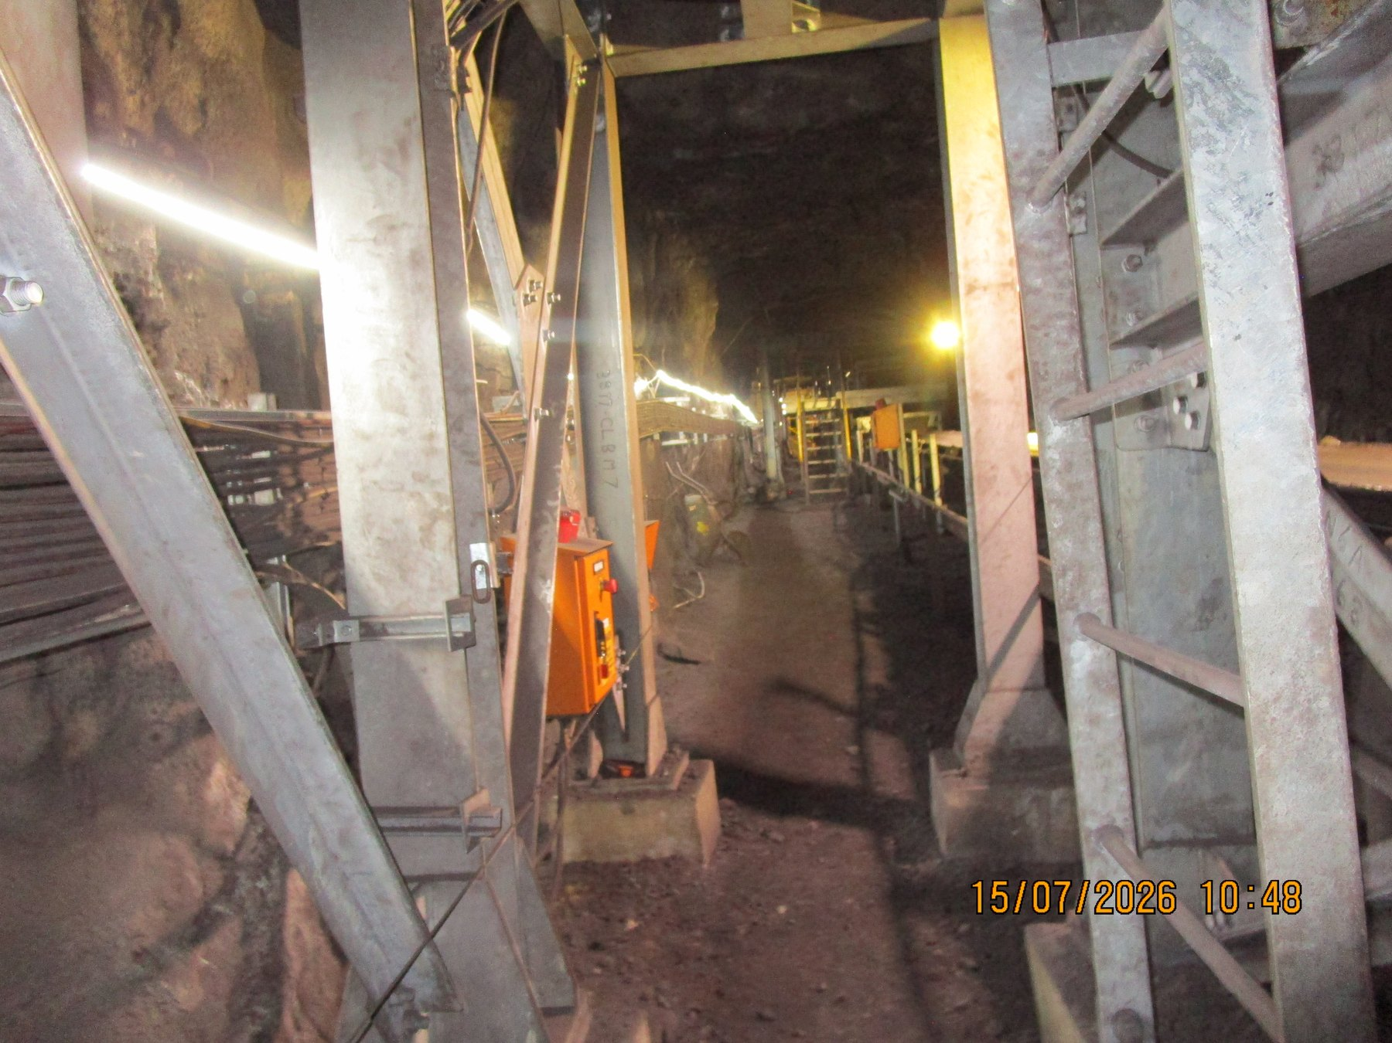  UG5B-REF-006 — wider comparator supporting a localised rather than uniformly widespread U5B condition.
PART IV — FINES, CARRYBACK AND CLEANER CONTAINMENT

8 Fines Are Being Lost Progressively Through the Conveyor Ecosystem
Recurring fines accumulation was observed across multiple underground and surface conveyor areas. The repeated relationship between deposits and return-belt/support-roller areas is consistent with carryback being a major recurring mechanism, particularly downstream of discharge locations. The photographs demonstrate the accumulated consequence, but they do not establish that every individual deposit has the same sole origin.
The cross-system recurrence is important because the visible deposit may occur some distance downstream of the cleaner or discharge point where residual material should originally have been controlled. Material remaining on the return belt can detach progressively as the belt flexes and passes over rollers; return rollers/idlers can dislodge and redistribute additional adhered fines. Wet or sticky fines can be more persistent, although the cleaner-control philosophy applies to both wet and dry residual fines and the report does not assume one common water source for all locations.
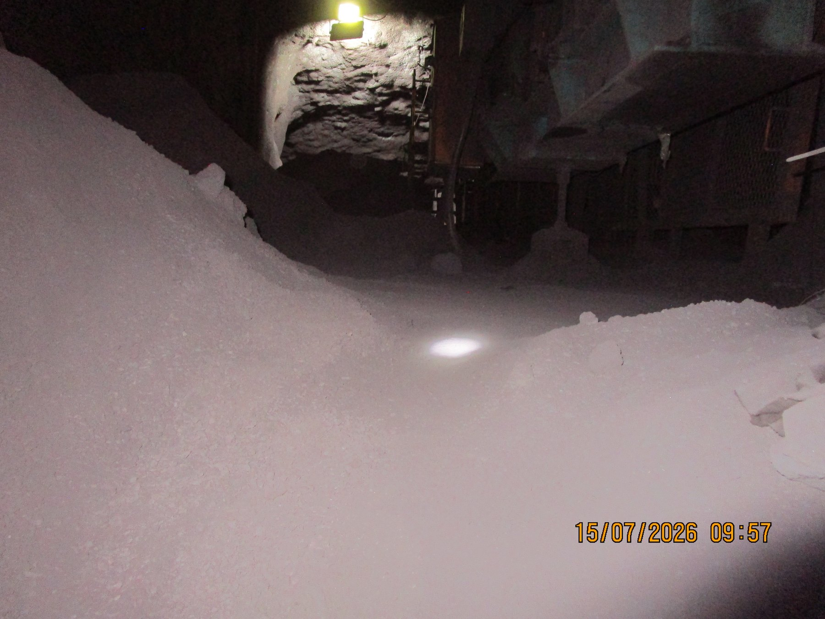  UGUC05_04_03_02_01-REF-015 — wider longitudinal accumulation supporting recurrence along the underground route. | 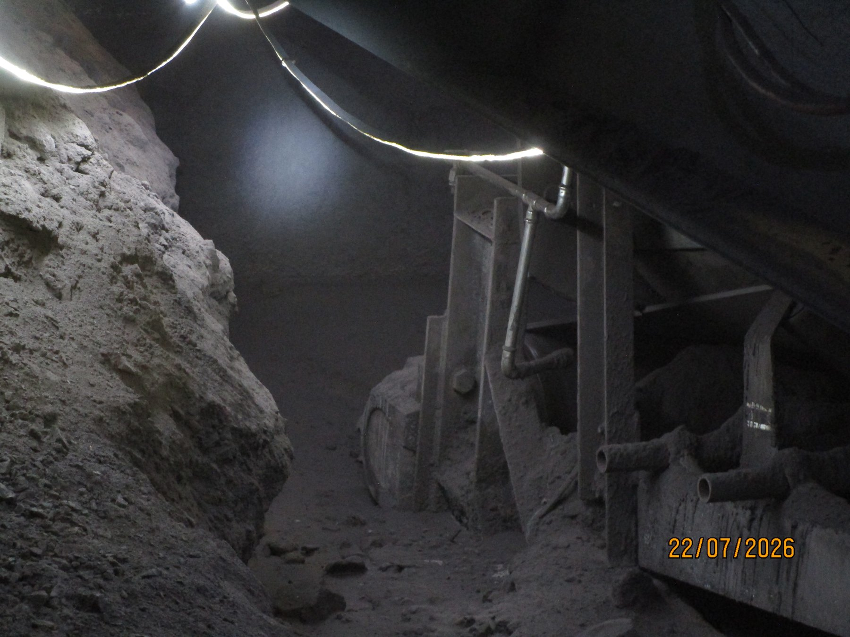  UG5A-REF-006 — widespread return-side accumulation at U5A.
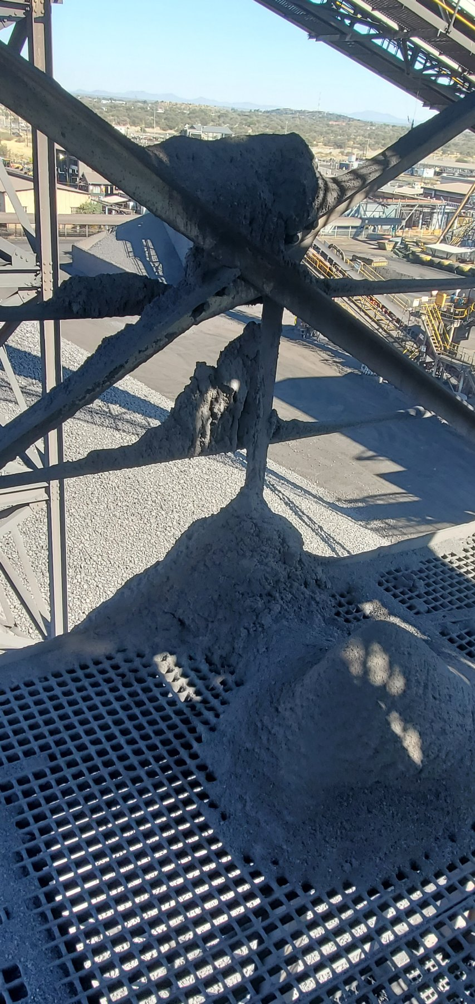  CV15-REF-004 — large fines deposits on grating/cross-bracing around the CV15 discharge region. | 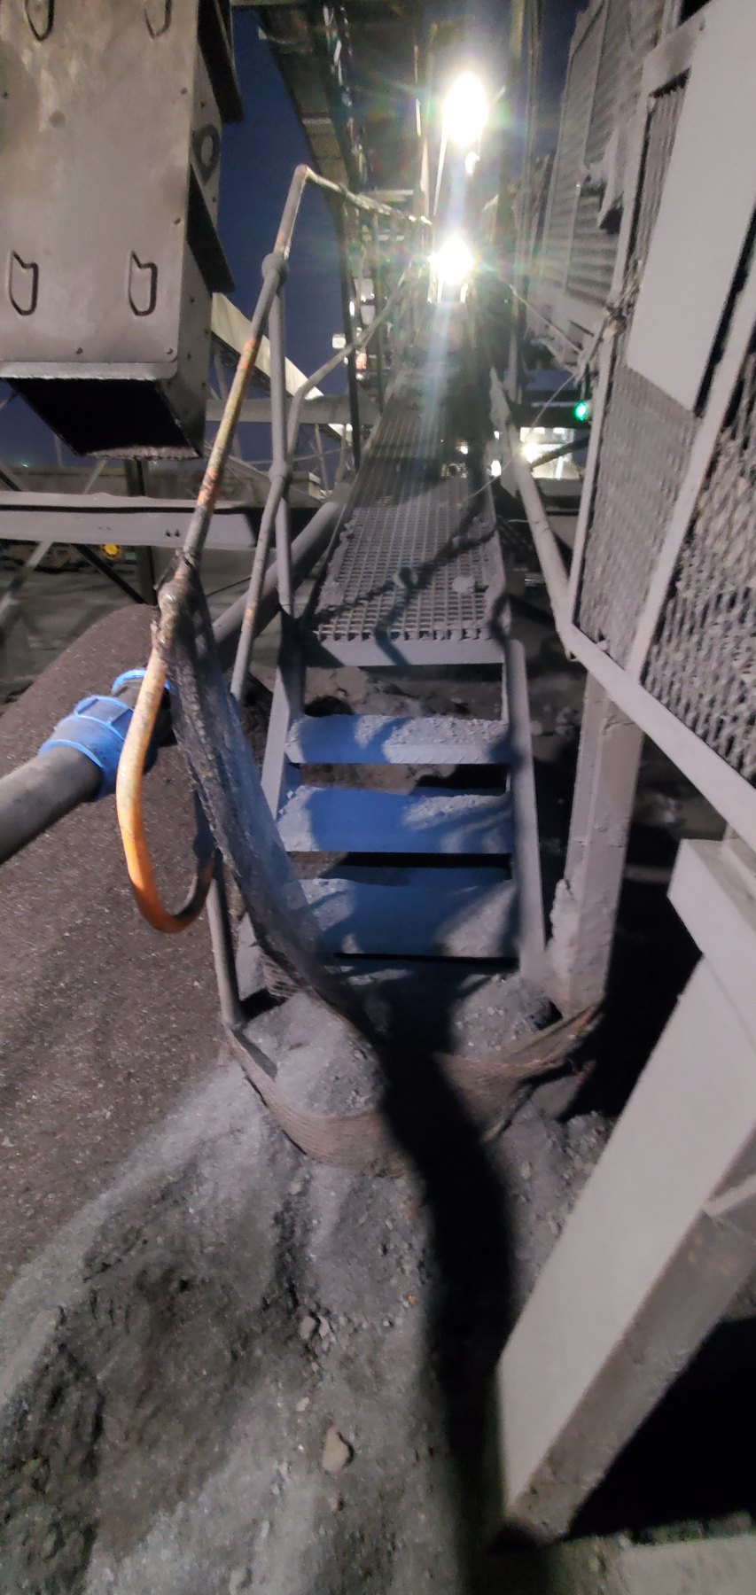  LoadoutStationSample1-REF-002 — substantial fines accumulation around the Sample Conveyor 1 tail/access area.
SYSTEM PATTERN | Carryback is a recurring system mechanism, not an isolated conveyor event. The report therefore focuses on cleaner function and containment at relevant discharges while retaining the evidence qualification applicable to each individual deposit.

9 Why Belt Cleaning Alone Is Not the Full Control Function
A belt cleaner succeeds only when two linked functions are achieved: residual material is removed from the belt before it progresses along the return run, and the removed material remains inside the intended discharge/process route. Across the inspected system, relevant cleaner deficiencies include missing blades, excessive wear, incomplete coverage or contact, reliance on manual adjustment, damaged/displaced support hardware, and cleaner location outside effective discharge containment. The source record also indicates that the conventional inspected cleaner arrangements do not use the proposed self-tensioning principle; as a wear element reduces, inadequate compensation can allow the belt/blade relationship to deteriorate and carryback to pass onto the return run. These deficiency types are not asserted to occur at every conveyor.
Source-recorded maintenance context described a four-days-operating / four-days-maintenance cycle, with section artisans and supervisors understood to have maintenance ownership. Formal cleaner inspection standards, blade-replacement criteria and maintenance records were not reviewed as part of this audit, and a mine-wide common cleaner design standard was not established. This context supports the recommendation to standardise the required cleaner function and verification method rather than assume identical installed hardware.

9.1 CV06 — Mechanical / Maintenance Failure Example
At CV06 the cleaner cannot perform its intended function because the physical cleaner condition is compromised. The support structure remains installed, but scraper blade elements are absent across the working belt width and a support bush/insert is displaced. Poor housing design was recorded as a probable contributor to the bush displacement, with maintenance/replacement condition also relevant, but the photographs do not establish the root cause or the history of blade loss. The first response is therefore to restore and verify a complete functional cleaner arrangement before considering broader redesign.
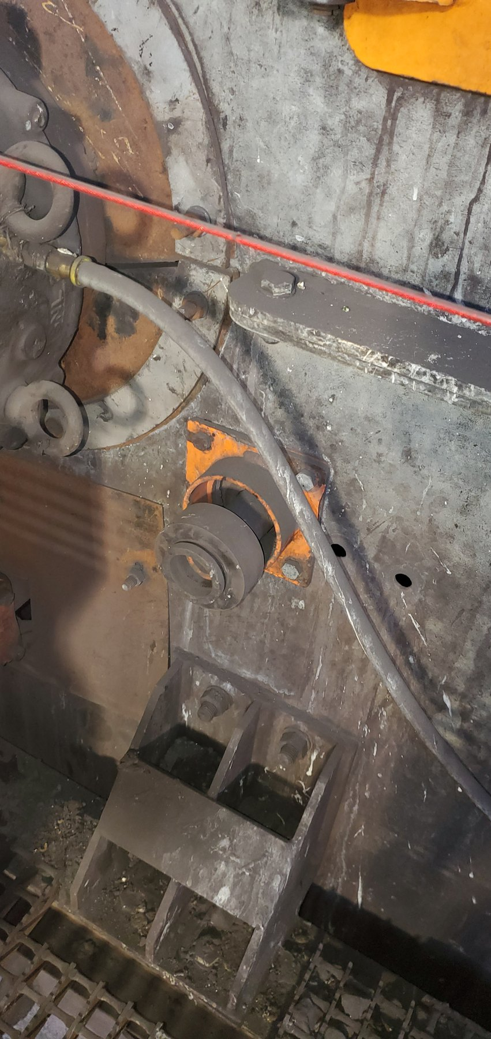  CV06-REF-004 — displaced cleaner support bush/insert. |  | 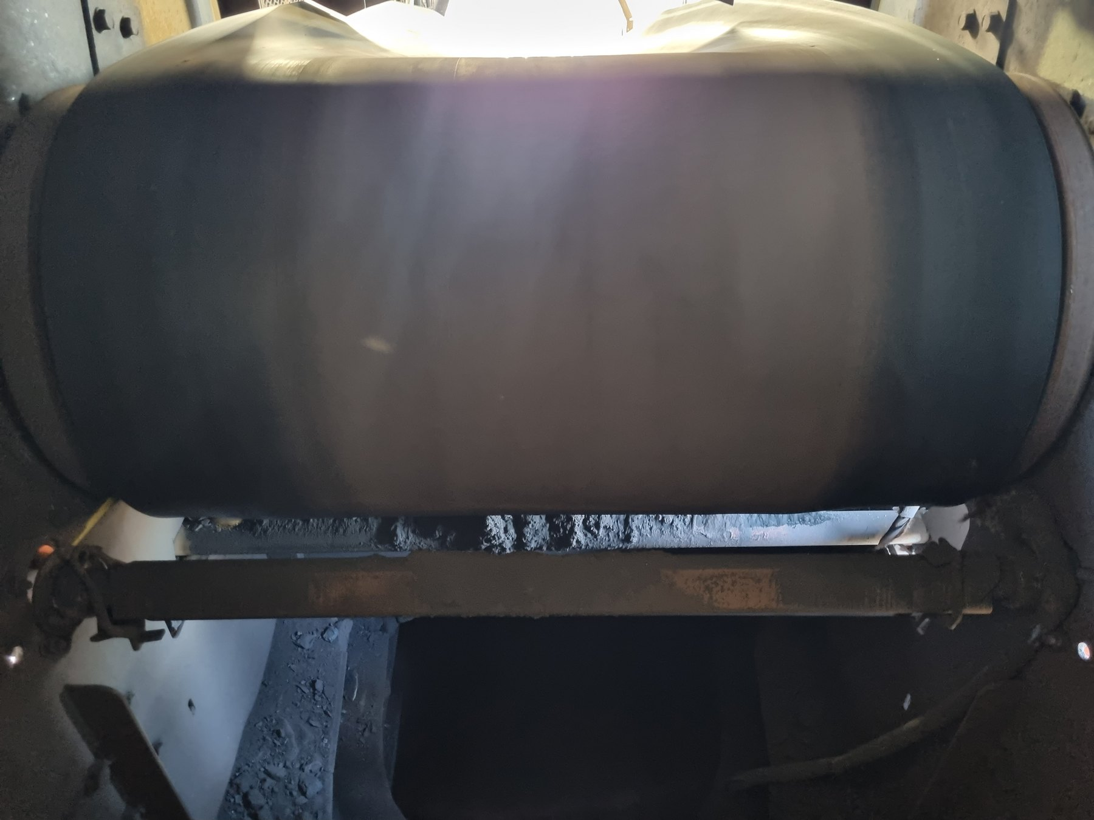  CV06-REF-005 — cleaner support structure present with scraper blades absent from the working belt width.
OBSERVATION | Physical cleaner defects are directly visible at CV06.
ENGINEERING ASSESSMENT | The cleaner is non-functional as intended. Poor housing design was source-recorded as a probable contributor to the displaced bush/insert, but the photographs do not prove the root cause. Blade-loss/removal history also remains unresolved.
RECOMMENDED NEXT ACTION | Restore a complete functional cleaner arrangement; inspect the housing/support condition and retention, reinstate required blade coverage, verify contact/adjustment and maintainability, and confirm representative operating performance before close-out.

9.2 CV09 — Cleaner Removes Material, But Containment Still Fails
CV09 demonstrates a different failure mode. The existing cleaner is outside/open to the effective head-chute discharge containment arrangement. It removes some wet residual material, but successfully removed material can fall directly into the surrounding plant area while residual carryback can continue onto the return run. Active wet-material fallout was recorded during operation. CV09 is therefore a useful pilot for proving belt cleaning and containment as one integrated control function.
The accepted functional objective is to remove residual fines before the belt enters the return run, with the cleaner acting while the belt is positively supported by the head pulley and with the cleaner stages located inside the existing head/discharge chute. This allows scraper-removed fines to fall naturally into the existing combined-product discharge flow rather than requiring a separate fines-recovery chute. Site geometry, mounting, access and the final OEM arrangement still require verification and detailed design.
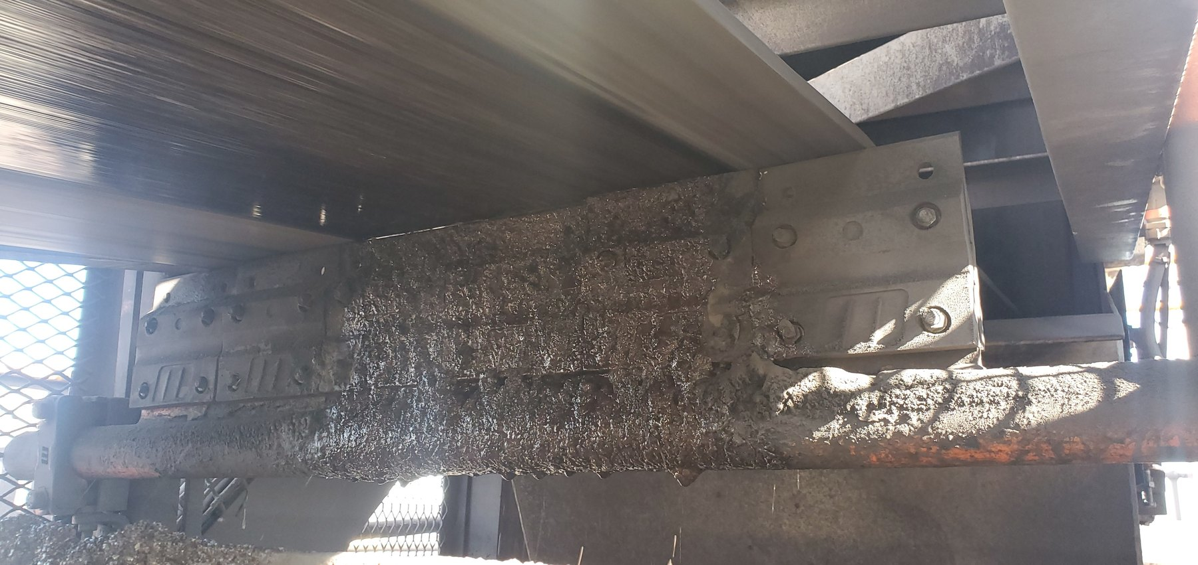  CV09-REF-003 — principal still showing the cleaner/open local arrangement. |  | 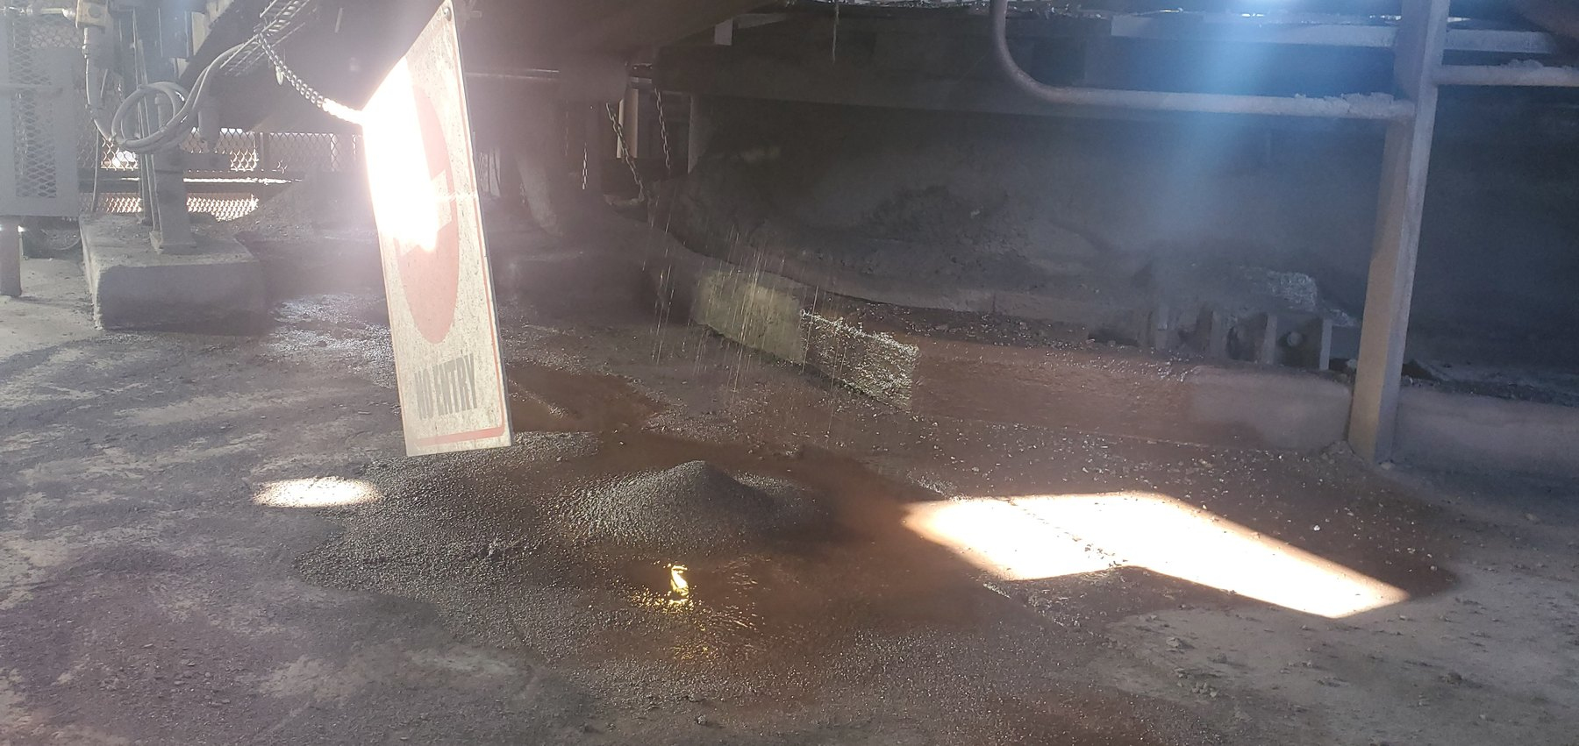  CV09-REF-002 — wet-fines/slurry consequence below the discharge/cleaner region.
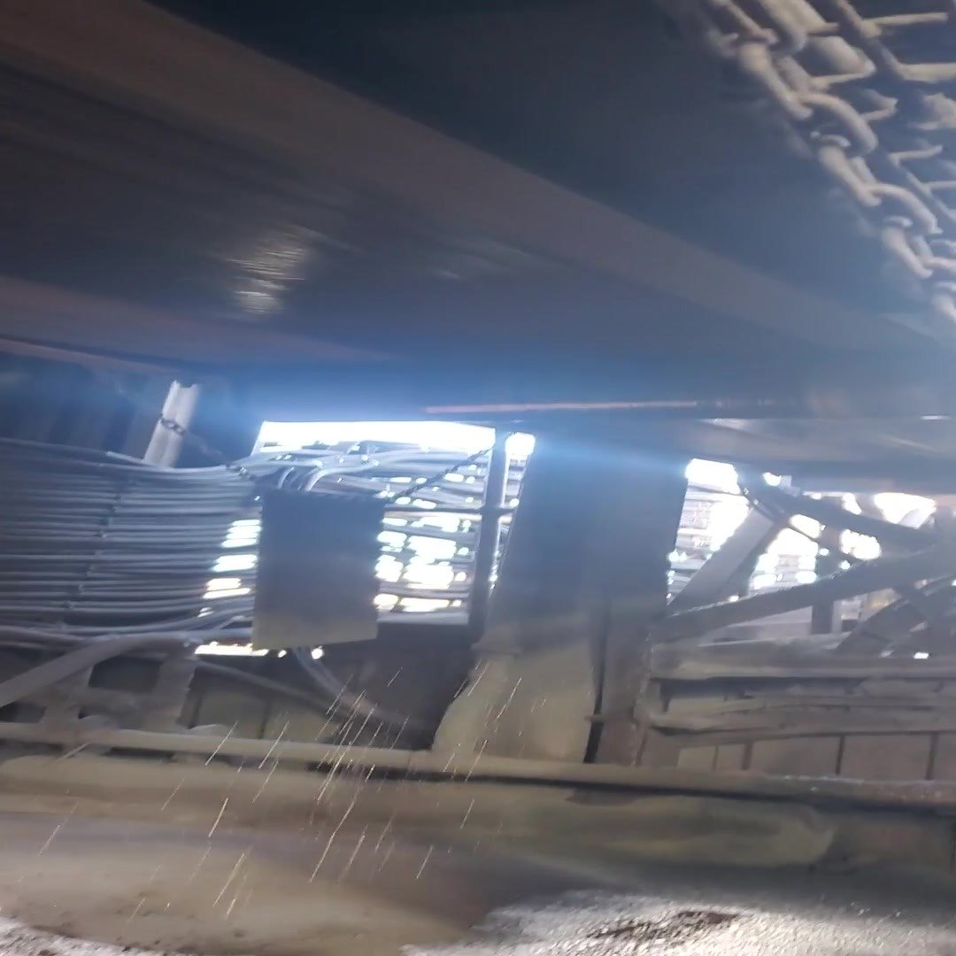  CV09-REF-006 — representative frame from inspection video showing active wet-material fallout during operation. |  | 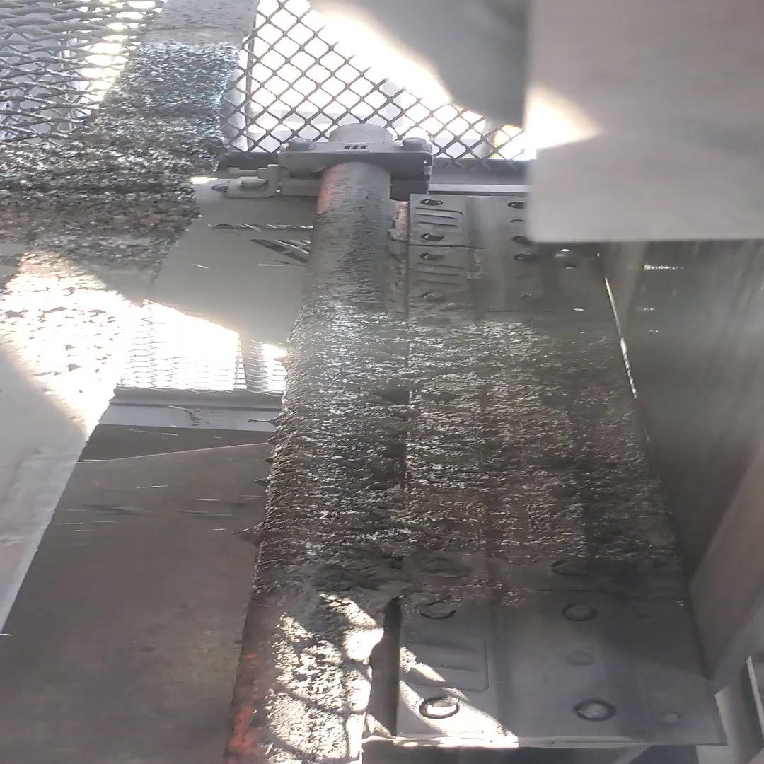  CV09-REF-008 — representative frame from inspection video showing contaminated cleaner/chute geometry relevant to the containment-boundary issue and pilot concept.
OBSERVATION | Wet fines/slurry are present below CV09 and active wet-material fallout was recorded during operation.
ENGINEERING ASSESSMENT | The existing cleaner can remove material from the belt, but its open/outside relationship to the effective head-chute containment allows successfully removed wet fines to become plant-area spillage. Residual carryback also remains possible downstream. Final OEM geometry and component detail remain open.
CONTROL PHILOSOPHY | Do not merely clean the belt. Keep the fines inside the process.
RECOMMENDED NEXT ACTION | Develop and trial the locked CV09 functional concept from verified site geometry: pulley-supported cleaning inside the head/discharge chute, preferred two-stage cleaning where feasible, controlled self-tensioning/wear compensation, positive travel limitation, practical maintenance access, and representative operating verification.

9.3 What CV09 Means Beyond CV09
Taken together, CV06 and CV09 show why the mine should standardise the required material-control function rather than one identical scraper arrangement. CV06 demonstrates loss of basic cleaner mechanical integrity; CV09 shows that even material successfully removed from the belt can still become spillage if it is not retained inside the discharge process. Wider rollout should therefore follow a proven functional standard — effective cleaning, stable contact through wear, positive travel limitation, mechanical integrity, removed material retained inside the process, maintainability and verified downstream performance — while the physical hardware remains location-specific. U4 remains an explicit geometry-specific exception.

10 Cleaner / Fines-Control Philosophy and CV09 Pilot
CV09 is the preferred pilot because its operating condition, cleaner/discharge relationship, active wet-material fallout and intended destination for removed fines can be related directly. The preferred/default arrangement is two pulley-supported cleaner stages acting before the belt enters the return run and located inside the existing head/discharge chute. Where verified constraints prevent two stages, at least one effective pulley-supported stage is the constrained minimum. The audit defines the required function; the OEM/detailed designer determines the final component geometry and specification.
- Locate the cleaner contact on the head-pulley-supported belt so the belt is mechanically stable at the cleaning point.
- Provide wear compensation/self-tensioning that maintains controlled cleaner-to-belt contact as the wear element reduces, together with a positive mechanical travel/wear stop.
- Use full-width cleaner blades/supports appropriate to the effective belt width, with guided movement through the chute-side support arrangement where required by the final design.
- Keep the cleaner stages inside the head/discharge chute so scraper-removed fines fall naturally into the existing combined-product discharge flow; no separate scraper-fines recovery chute is required at the cleaner.
- Retain safe inspection, adjustment, blade/wear-element replacement, guarding and clean-out access.
- Verify final cleaner type, materials, angles, forces, spring rates, supports/slots, structural attachments, travel values, dimensions and tolerances through the OEM/responsible detailed-design process.
STANDARDISE THE FUNCTION | This is not a recommendation to install one identical scraper at every conveyor. Prove the required cleaner/containment function at CV09, then assess each applicable location for its own mechanism, belt/material condition, chute geometry, maintenance access and safe installation space. U4 remains a geometry-specific exception.
The pilot should be judged by sustained performance rather than by the appearance of the area immediately after installation. Downstream carryback should be materially reduced relative to the pre-trial condition; removed fines should remain inside the discharge process; cleaner contact should remain stable through the agreed wear condition; and no unacceptable belt wear, cleaner wear, guarding, trapping or maintenance-access problem should be introduced. The monitoring record should be sufficient to support or reject wider functional rollout.
FIGURE CONTROL — Historical CTD-001 is superseded for active report use. The accepted CV09 communication set is CTD-005 / DRAW-005 (preferred cleaner placement/orientation reference) together with CTD-006 / DRAW-006 (cleaners inside head-chute containment principle). Final binary placement and external-reference source/reuse confirmation remain part of the later figure/evidence assembly pass.
CV09 figure-control reference — CTD-005 + CTD-006 govern V0.6; historical CTD-001 is retained only for development traceability.
PART V — COARSE / COMBINED-PRODUCT LOSS DURING TRANSIT

11 The Containment Problem Is Not Limited to Fines
The inspection also identified locations where coarse/lump or mixed product had left the carrying belt during transit. These conditions differ from return-side fines/carryback and require controls focused on keeping product within the usable carrying area until the intended transfer or discharge. Relevant factors can include feed quantity and variation, product-size distribution, loading position/trajectory, usable belt width, mistracking, transfer geometry and local side containment.
The preferred sequence is to establish the loss mechanism and verify feed/geometry first, correct primary contributors where practicable, and then determine the genuine residual containment duty. Where residual lateral escape remains, a belt-compatible side skirt/spill seal should act at the belt carrying edge; a remote external barrier after product has already escaped is not the preferred material-control principle.

12 W10 — Coarse Product Loss in a Confined Tunnel
W10 is significant because substantial coarse/mixed-product accumulation is present outside the intended belt path in a confined tunnel. The photographs establish the consequence and restricted access geometry, but they do not isolate one definitive initiating cause for every deposit. The accepted residual-containment concept is therefore not a walkway barrier: it is flexible belt-compatible side skirting/spill sealing installed along the conveyor sides so laterally moving product is retained on the belt.
The tunnel/access restriction increases the consequence and housekeeping difficulty but does not define the design objective. Primary contributors such as loading, feed distribution, tracking and local geometry should still be investigated and corrected where present. Where residual containment is required, the active skirt/seal should sit on the inside of the conveyor carrying width along the troughed belt edge, forming a near-vertical containment boundary with a belt-friendly lower sealing relationship selected by the OEM. It should not act as a rigid belt guide or create damaging rubbing, product trapping or inaccessible build-up zones.
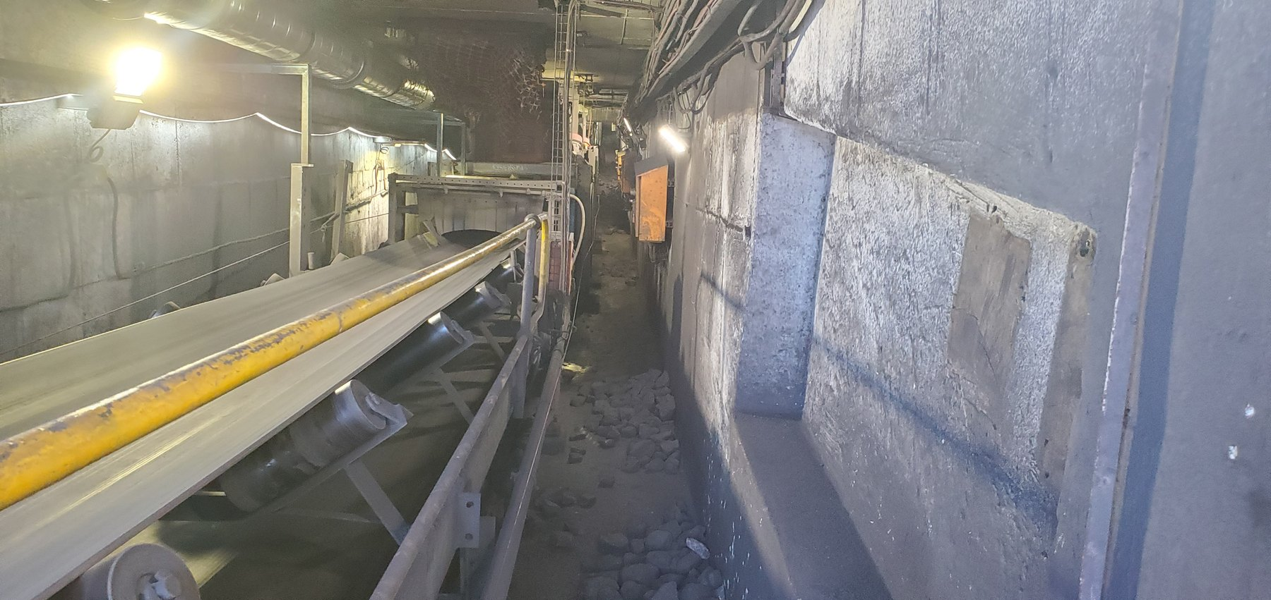  W10-REF-010 — long tunnel view establishing the confined topology and restricted access. |  |   W10-REF-002 — principal coarse/mixed-product consequence in the access route.
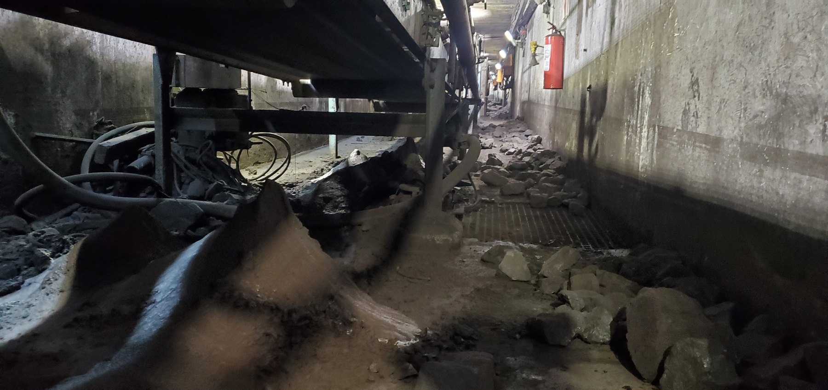  W10-REF-006 — product distributed below the conveyor around components, explaining local geometry. |  | 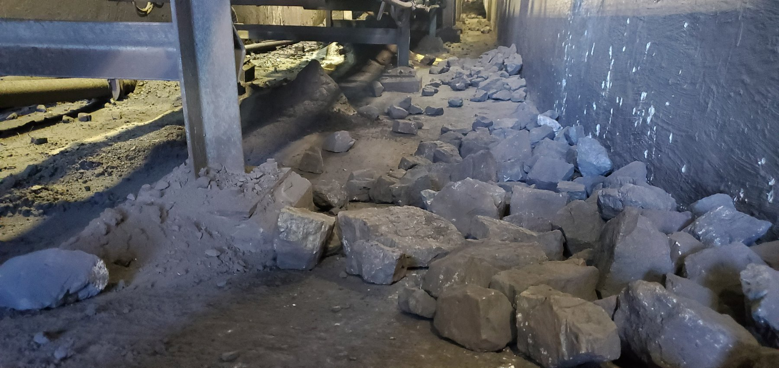  W10-REF-009 — product immediately beside support steel; useful context for local side-containment feasibility.
OBSERVATION | Coarse/mixed product has escaped the intended carrying path and accumulated in a confined access tunnel.
ENGINEERING ASSESSMENT | The exact initiating mechanism remains unresolved. The accepted secondary/residual control is belt-edge side skirting/spill sealing within the carrying width, not a remote external walkway barrier. Loading, tracking and local geometry remain primary investigation items.
RECOMMENDED NEXT ACTION | Verify representative loading/tracking and local belt/trough/support geometry; correct confirmed primary contributors; then define the residual side-containment duty and install/adapt belt-compatible skirting/spill sealing as required. Verify belt-friendly operation, clean-out/access, wear and representative containment performance.
FIGURE CONTROL — Historical CTD-002 external-barrier interpretation is superseded. Active W10 concepts are CTD-010 / DRAW-0010 (site/tunnel context and skirting position) and CTD-011 / DRAW-0011 (side-skirt/spill-seal cross-section). Final binary placement is deferred to the dedicated figure/evidence assembly pass.
W10 figure-control reference — CTD-010 + CTD-011 govern V0.6; historical CTD-002 is retained only for development traceability.

13 Sample Conveyors — Product Size, Feed and Limited Carrying Width
Sample Conveyors 2 and 3 show a combined geometric containment problem in which feed quantity/variation, product-size distribution, loading position, usable belt geometry and lateral belt position can interact. The photographs do not establish that rated/design throughput capacity has been exceeded. A conveyor can be below rated throughput and still lose product where large product, off-centre distribution or reduced usable carrying margin challenges the local containment geometry. The correct sequence is therefore to establish design basis and feed control, verify representative product size and loading centring, quantify/correct tracking and interference, reassess corrected carrying geometry, and only then define any residual side-skirt/spill-seal duty.
CONTROL HIERARCHY | 1. Establish intended/design basis and actual feed quantity/variation. 2. Verify representative product-size distribution and loading position/centring. 3. Quantify and correct tracking/alignment/interference under representative loading. 4. Reassess corrected usable carrying geometry and remaining feed/product controls. 5. Install/adapt belt-compatible side skirting/spill sealing only for verified residual duty. 6. Verify the complete feed → product size → loading → tracking → containment relationship in operation.

13.1 Sample Conveyor 2
At Sample Conveyor 2, coarse/lump product occupies a substantial proportion of the narrow available carrying geometry and material is visible outside the intended carrying path. The current evidence overlay also supports a captured lateral belt-offset condition through the REF-004/REF-005 pair. The magnitude, persistence/frequency and initiating cause of that offset are not established, and the photographs do not prove quantitative design-capacity overload. Feed quantity/variation, product-size distribution, loading position, belt position and local congestion therefore need to be considered together.
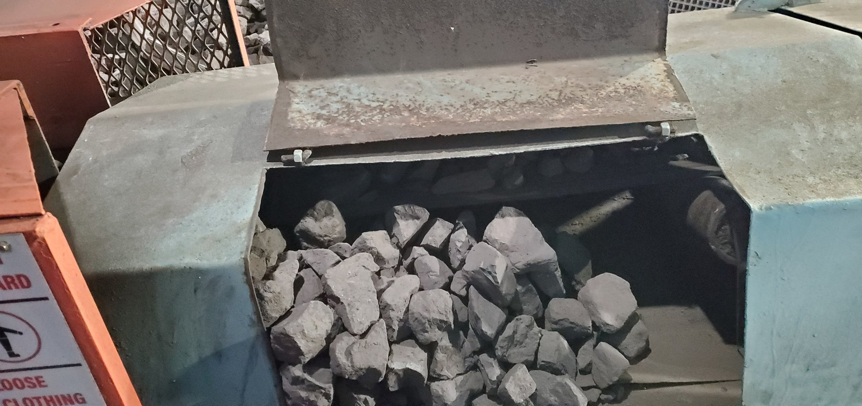  LoadoutStationSample2-REF-004 — coarse product occupying a substantial proportion of the narrow belt width. | 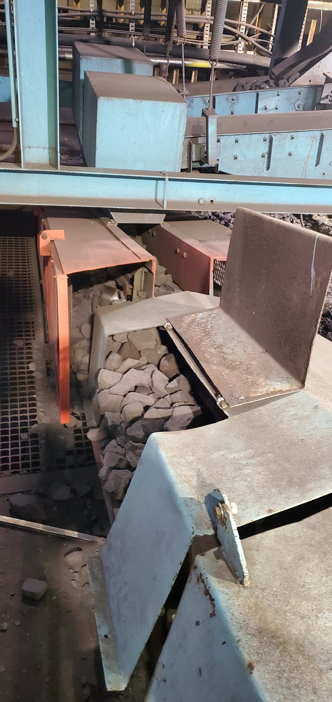  LoadoutStationSample2-REF-006 — product accumulated through/around the local enclosure and outside the intended carrying path. | 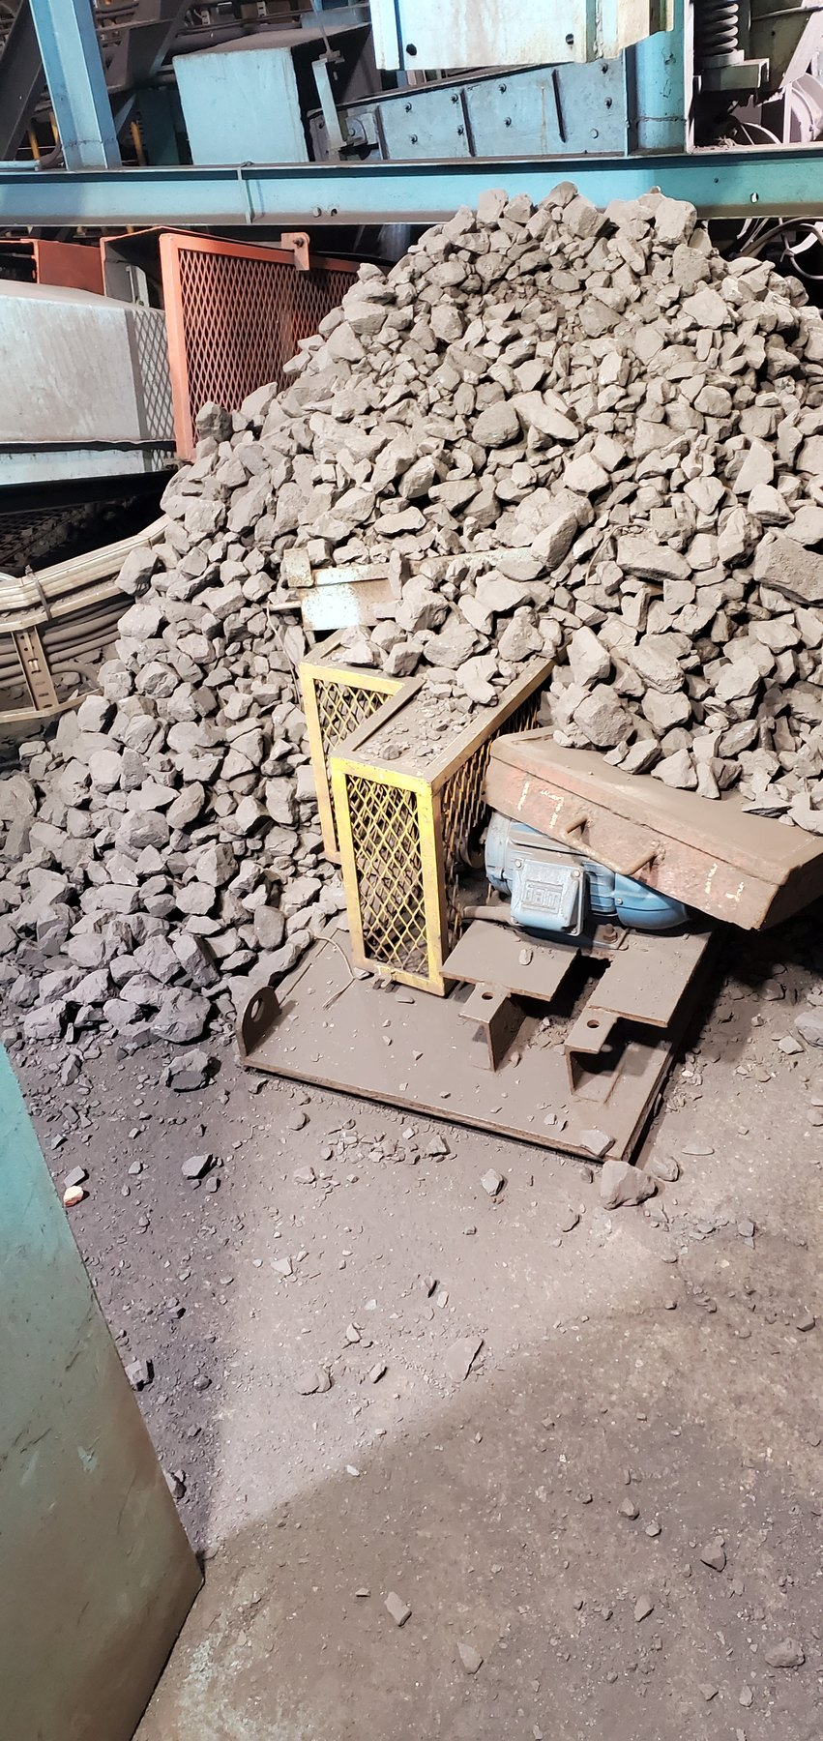  LoadoutStationSample2-REF-001 — extensive surrounding lump-product accumulation.
The recommended response is to establish the intended duty and actual feed-control arrangement, observe representative loading/product size, verify centring/distribution, quantify the captured tracking/offset condition and inspect the congested entry/guide interaction zone. Confirmed primary contributors should be corrected first. Only after acceptable centred operation and usable carrying geometry are established should any remaining side-skirt/spill-seal duty be defined. Current body reasoning uses REF-004 + REF-001 for the opening condition/consequence, REF-004 + REF-005 for the product-size/offset relationship, REF-007 for loading/product-size context and REF-006 for the congested interaction zone.

13.2 Sample Conveyor 3
Sample Conveyor 3 combines the same narrow-belt/product-size containment pressure with a visually substantial lateral belt offset supported by the correctly attributed REF-006/REF-007 pair. The offset remains unmeasured and the mechanical root contributor is unresolved. The report therefore requires representative feed/product-size/loading verification, quantitative tracking/alignment diagnosis and correction, followed by reassessment of the residual containment duty. REF-013 is withdrawn from the active evidence population and must not be used as Sample Conveyor 3 evidence.
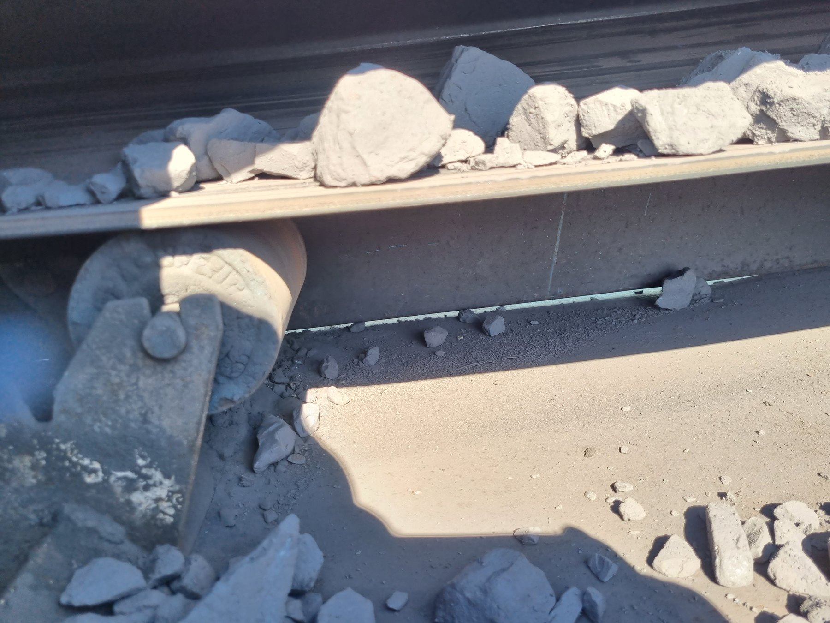  LoadoutStationSample3-REF-005 — large lumps occupying much of the available narrow belt width. |  | CURRENT EVIDENCE CONTROL  Principal lateral-offset evidence is LoadoutStationSample3-REF-006 + REF-007. REF-013 has been withdrawn because it belongs to another conveyor/belt and cannot be reliably reassigned; it must not be used in the report or appendix evidence set.
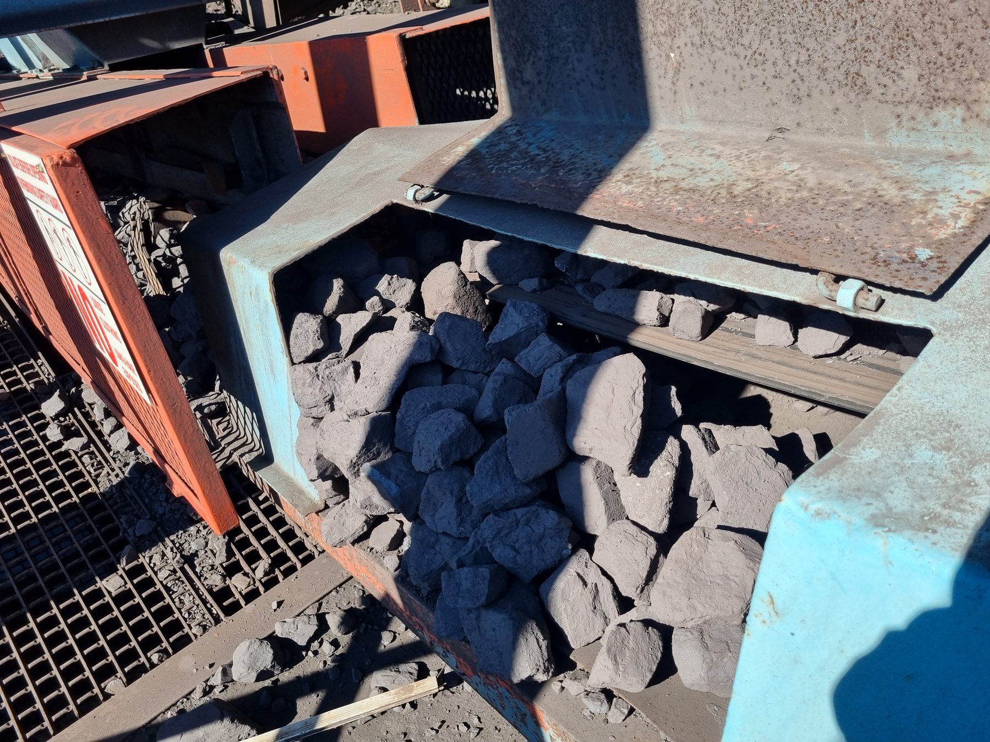  LoadoutStationSample3-REF-002 — coarse product accumulated around/outside the intended belt path. |  | 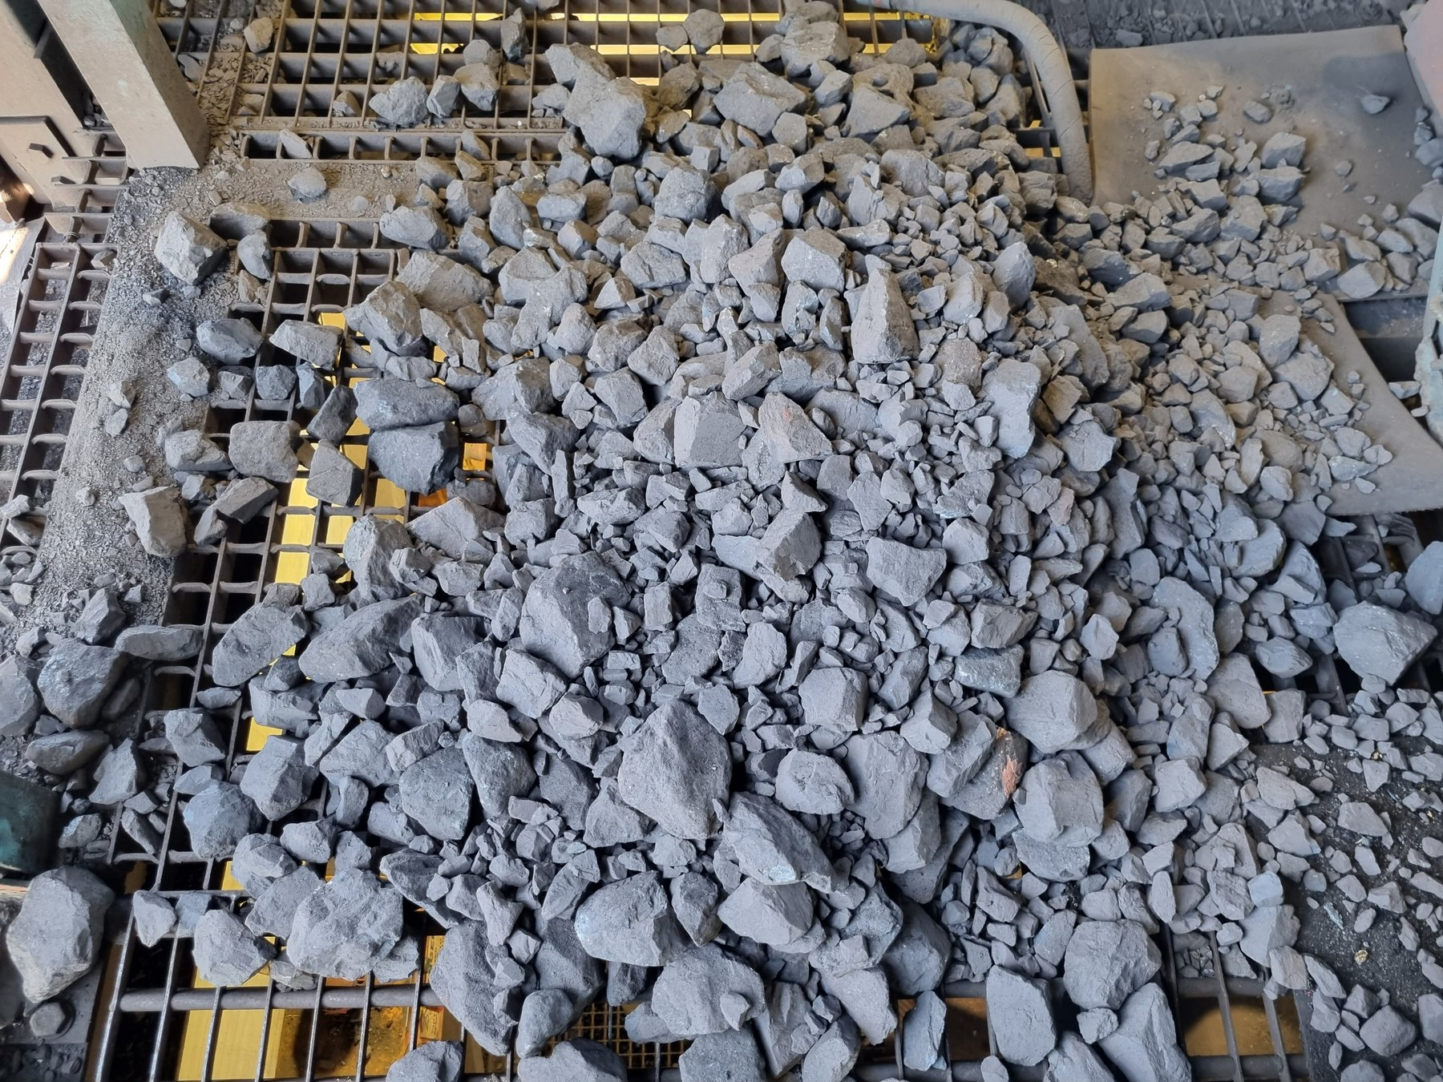  LoadoutStationSample3-REF-012 — extensive mixed-size accumulation on surrounding grating/access.
OBSERVATION | Product-size/available-width pressure and significant surrounding spillage are visually established. A visually substantial lateral belt-offset condition is also supported by the current REF-006/REF-007 evidence pair; its magnitude remains unmeasured.
ENGINEERING ASSESSMENT | The evidence does not justify a percentage or millimetre offset and does not prove whether head/tail alignment, tension, local interference, trapped material or another mechanical condition is the root cause. Feed/product size/loading and tracking must be evaluated together.
RECOMMENDED NEXT ACTION | Establish design/feed basis; verify representative product size and loading centring; quantify and correct tracking/alignment/interference; prove centred operation; then define any residual belt-compatible side-skirt/spill-seal duty and verify performance.
Question | Sample Conveyor 2 | Sample Conveyor 3
Loading / carrying-width concern | Supported | Supported
Significant mistracking established by current evidence | Yes — captured lateral offset supported; magnitude/persistence/root cause unverified | Yes — visually supported
Offset magnitude measured | No — measurement required | No — measurement required
Primary next step | Verify design/feed/product/loading + quantify/correct tracking | Verify feed + quantify/correct tracking
Secondary containment | Only after primary feed/loading/tracking contributors are verified/corrected and residual duty confirmed | Only after feed/tracking correction and residual duty confirmed
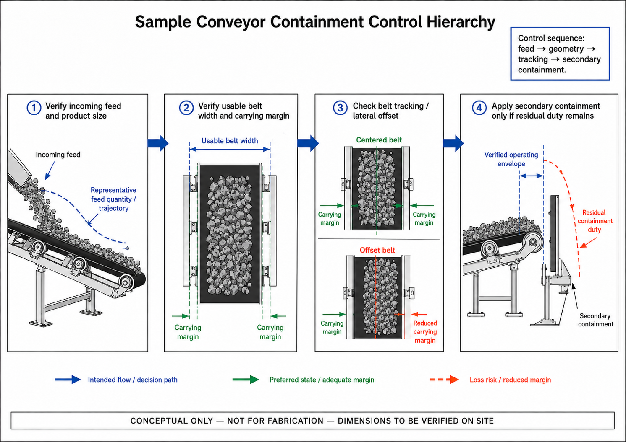
CTD-003 — Sample Conveyor Containment-Control Hierarchy. Conceptual only; not for fabrication; site geometry to be verified.
PART VI — ALIGNMENT AND LOCAL PRODUCT-LOSS MECHANISMS

14 Belt Tracking as a Material-Containment Requirement
A carrying belt can use its full containment margin only when it remains suitably centred relative to the supporting structure. Lateral displacement reduces the usable carrying margin on one side and can expose coarse/mixed product to the edge of the usable carrying area. Tracking is therefore both a mechanical condition and an important part of material containment.

15 U4 Tripper Car — Strong Local Cause-and-Effect Example
U4 provides one of the clearest local relationships between lateral belt displacement and a one-sided coarse-product consequence. The inspector-recorded tail-pulley/alignment concern is visually supported but not dimensionally proven. The current evidence story is REF-008 (tail-pulley/alignment context) → REF-009 (strongest visible lateral mistracking) → REF-004 (displacement continuing toward the tripper) → REF-007 (predominantly one-sided larger/coarse-product accumulation). This sequence supports the engineering relationship but must not be written as frame-by-frame dynamic chronology. A separate fines-accumulation condition is supported by REF-005 + REF-006. Earlier operating context also described the alignment relationship as fixed relative to the tripper structure and the loss as position-dependent, which reinforces the need for verification through the full normal tripper travel.
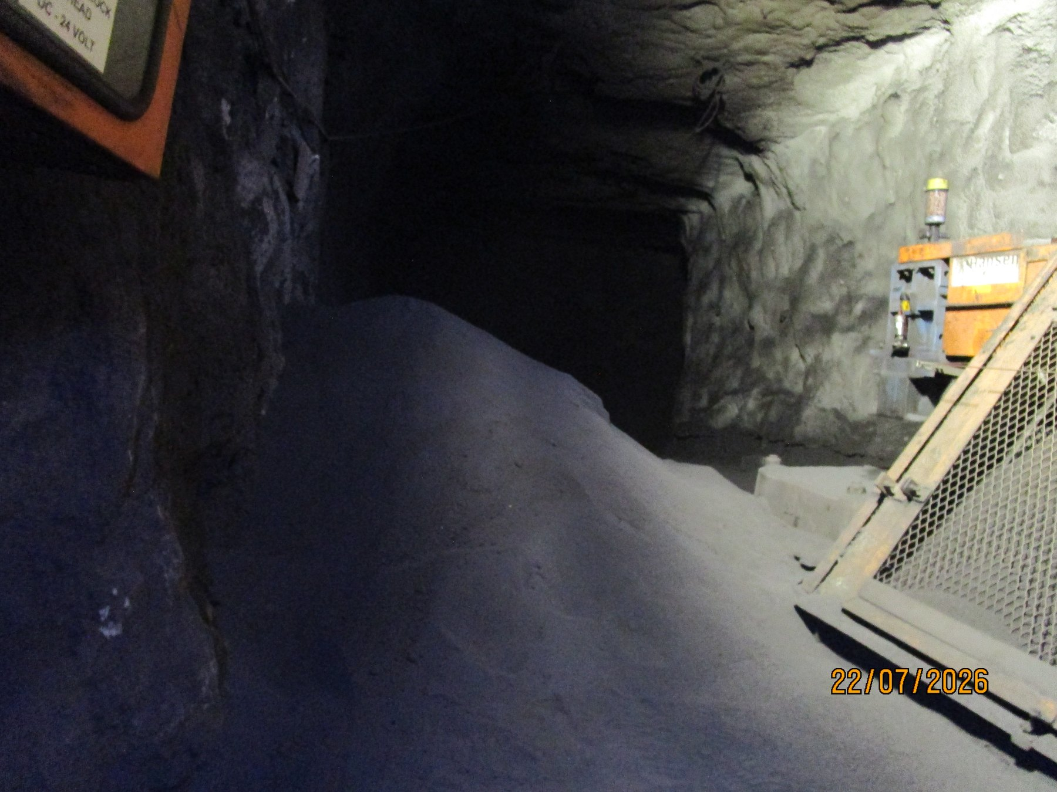  UGU4-REF-006 — essential evidence of substantial fines build-up in the head-pulley/tripper discharge region; treat as a separate fines/carryback condition rather than the coarse-product tracking sequence. |  | 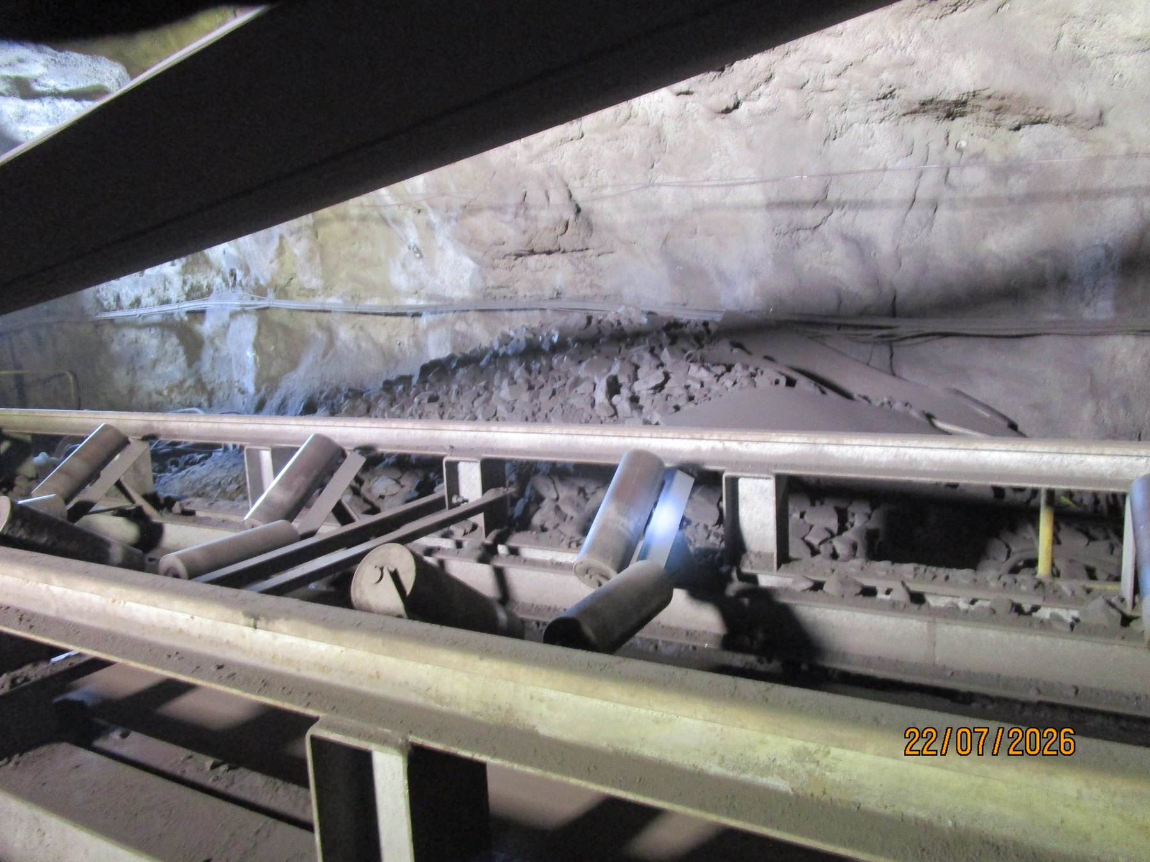  UGU4-REF-007 — principal one-sided larger/coarse-product accumulation consequence evidence. The image shows accumulated consequence, not the instant each piece left the belt.
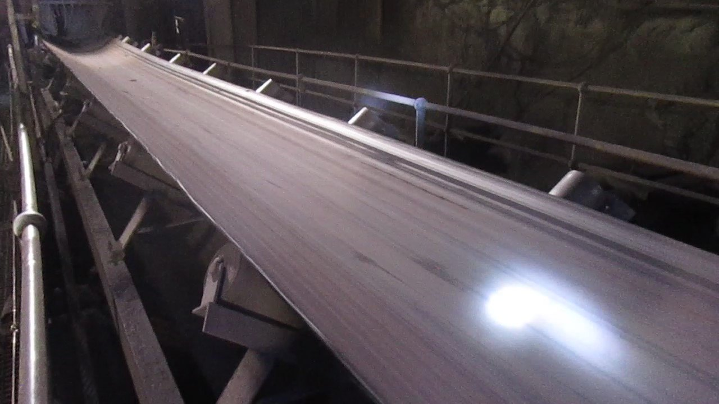  UGU4-REF-009 — strongest still showing visible lateral mistracking downstream of the tail-pulley/alignment region. |  | CURRENT U4 STORY CONTROL  Principal tracking-to-consequence sequence: REF-008 → REF-009 → REF-004 → REF-007. Separate fines pair: REF-005 + REF-006. REF-011/012 are appendix/reference and remain valid only for the materially different U4 cleaner arrangement.
OBSERVATION | Lateral mistracking and a one-sided coarse-product consequence are visually supported. The tail-pulley/alignment concern is inspector-recorded and visually supported but not quantitatively proven.
ENGINEERING ASSESSMENT | The evidence supports an alignment/tracking concern and one-sided consequence relationship, but final mechanical cause must be established by measurement. The substantial fines build-up is a separate condition. U4 uses a materially different/custom cleaner/discharge arrangement and is not an automatic CV09 cleaner candidate.
RECOMMENDED NEXT ACTION | Quantify the as-found belt/tail-pulley relationship; inspect pulley/idlers/tension/training/tripper geometry and local interference; correct confirmed contributors; prove acceptable centred tracking throughout normal tripper travel under representative loading; reassess coarse loss and fines separately; determine residual containment only afterward.

16 L3 — Alignment Concern Without Proven Solid-Product Causal Chain
L3 is deliberately treated more conservatively than U4. REF-001 supports an asymmetric tail-end belt/pulley relationship consistent with an alignment/tracking concern, while REF-002 + REF-004 + REF-007 provide the principal fines/material accumulation story and REF-008 is supporting lower-area context. The offset magnitude is unmeasured and the current evidence does not establish that the alignment concern is responsible for significant coarse/lump-product spillage. The required response is to quantify the tail-end relationship and live tracking, correct any confirmed defect, then reassess the fines condition separately without retrospectively creating an unsupported solid-product causal chain.
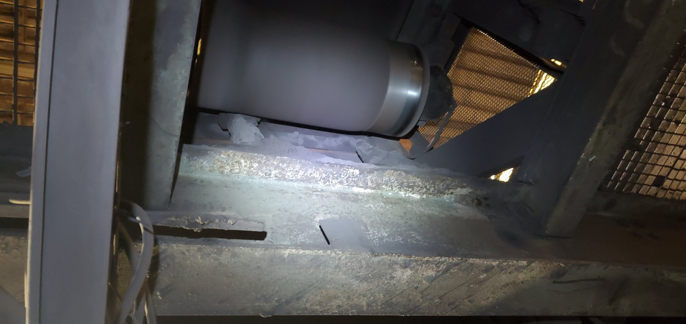  LoadoutStationL3-REF-001 — tail-end asymmetric belt/pulley relationship supporting the recorded offset; quantitative alignment measurement remains required. | 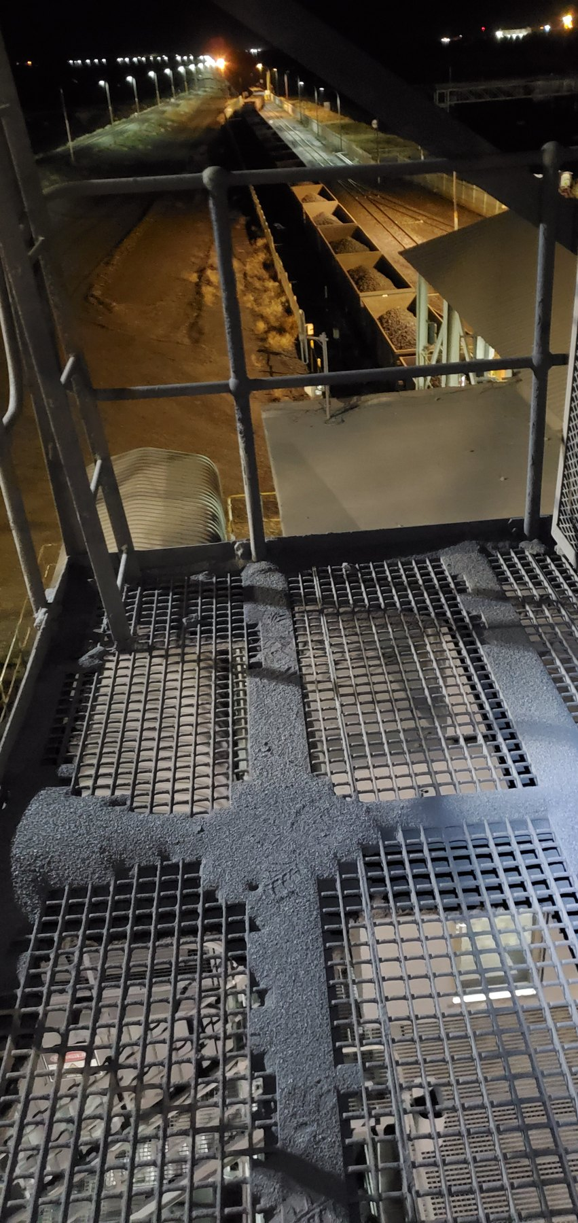  LoadoutStationL3-REF-007 — one of the principal fines/material accumulation views. Current fines set: REF-002 + REF-004 + REF-007; REF-008 is supporting lower-area context.
EVIDENCE DISCIPLINE | A mechanical alignment finding becomes a material-loss conclusion only to the extent that the evidence supports the connection. U4 supports tracking plus directional product loss; L3 presently supports an alignment/offset concern requiring quantitative verification.
Evidence question | U4 | L3
Offset / tracking concern supported | Yes | Yes
Alignment magnitude measured | No | No
Directional significant coarse-product loss linked | Strongly supported | Not established
Close-out | Measure, correct, prove full-travel tracking | Measure, correct/disposition, observe live tracking and local consequence
PART VII — WATER, WET FINES AND STRUCTURAL CONSEQUENCES

17 Water as a Material-Transport and Deterioration Mechanism
Water introduces a different containment problem. When process or cleaning water leaves its intended process route, it can mobilise fines, create slurry, spread contamination away from the source, increase slip/housekeeping demand and contribute to repeated wetting exposure of surrounding equipment. Source-recorded examples of water introduction elsewhere include dust-suppression sprays, hose cleaning and high-pressure water used in some blockage/silo conditions; these examples are not asserted to occur continuously or universally across the plant. At the Screens, active process-water escape is directly proven and must be investigated as its own mechanism.
The report therefore distinguishes directly observed process-water escape from locations where water or wet fines are visible but the initiating source remains unresolved. Water containment and structural condition are also treated as separate workstreams: repeated wetting can be relevant to deterioration, but the available evidence does not establish one water source as the sole cause of all corrosion or structural damage.
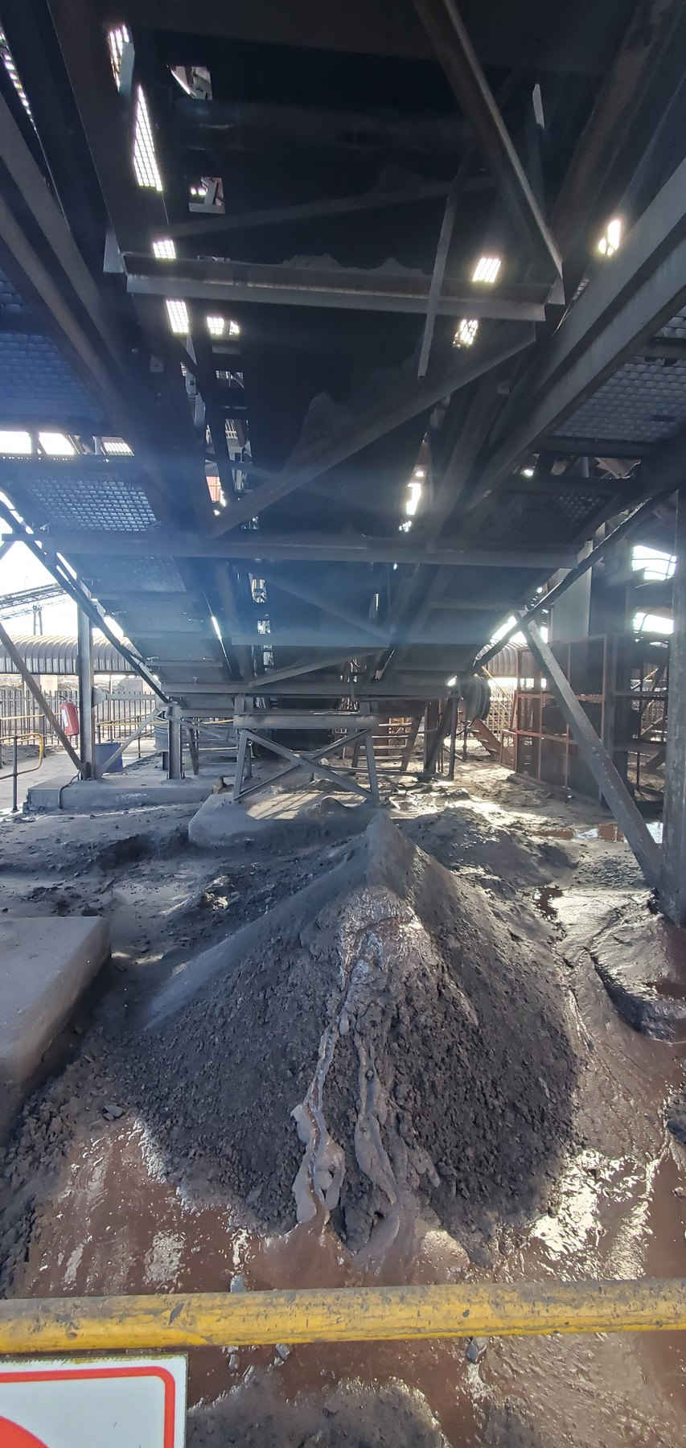  CV01-REF-003 — principal wet-fines/slurry consequence with pooled water/slurry; exact water source unresolved. |   CV04-REF-002 — saturated wet-fines/slurry with visible wet fallout/droplets. | 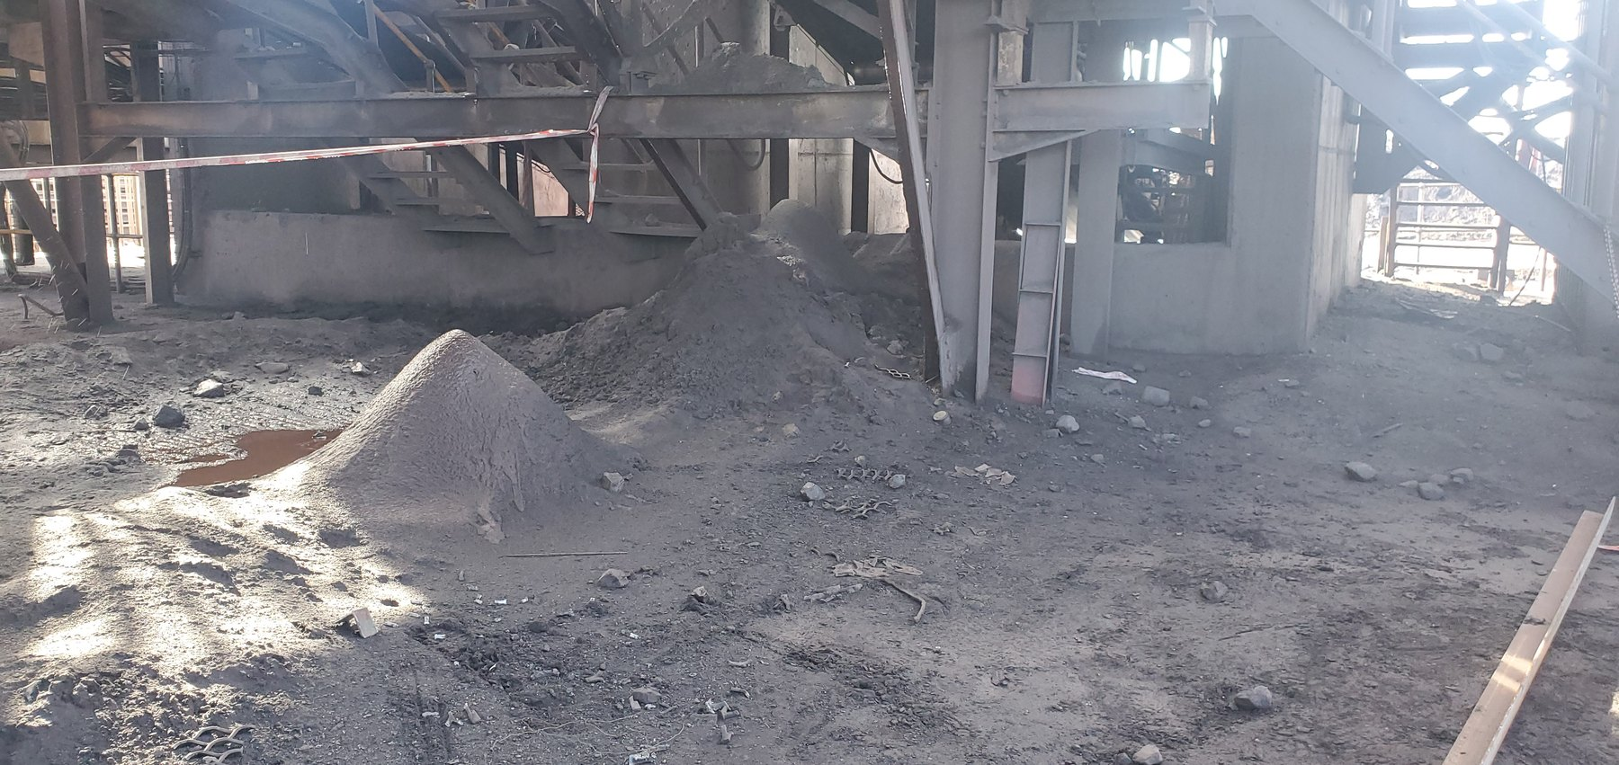  CV04-REF-005 — wider extent of multiple fines piles supporting the widespread CV04 condition.

18 Screens — Confirmed Water Escape / Separate Structural Story
The Screens evidence contains three related but distinct stories: active process-water loss of containment, severe corrosion/deterioration, and physical cut-outs/notches/openings in support members. Screen-REF-016 provides direct operating proof of active spray/water escape; Screen-REF-017 gives the strongest external localisation of the point where the water emerges. Because the equipment was operating, the internal section could not be safely accessed and the internal component/defect producing that external escape remains unresolved. The appropriate sequence is therefore to use the videos to mark the external emergence location, isolate the screen during a planned shutdown, inspect the corresponding internal area, identify the first actual mechanism by which water leaves the intended screening/washing/chute process path, correct that verified mechanism and then re-test the previously identified location under representative operation.
The structural condition requires a separate competent assessment. Current corrosion evidence prioritises REF-002 + REF-003 as the principal close/context pair, with REF-004 supporting and REF-008 retained for broader severity/extent. Current altered-member evidence prioritises REF-009 + REF-010, with REF-006 supporting. The cut-outs/notches are physically proven, but their reason/history and remaining structural capacity are not. Possible explanations based on general industrial experience — such as installation convenience or accommodation of different replacement equipment — remain unverified background hypotheses and are not report conclusions. A competent structural authority should establish member role/load path, dimensions, cut geometry, section loss and connection condition, determine remaining adequacy and specify any required interim controls and engineered repair/strengthening/replacement, followed by formal as-left acceptance.
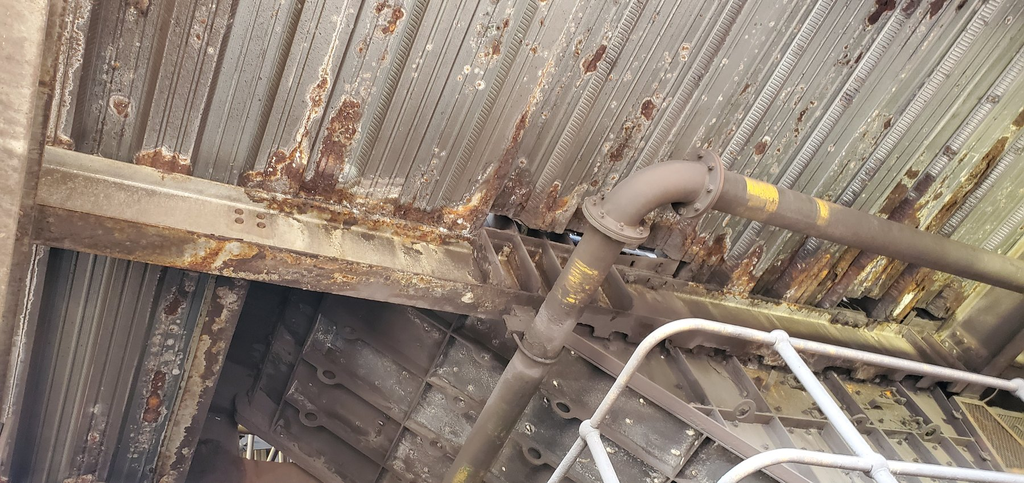  Screen-REF-003 — wider screen/chute structural context. Current corrosion body priority pairs REF-002 + REF-003; REF-002 is to be placed during final evidence-plate assembly. |  | 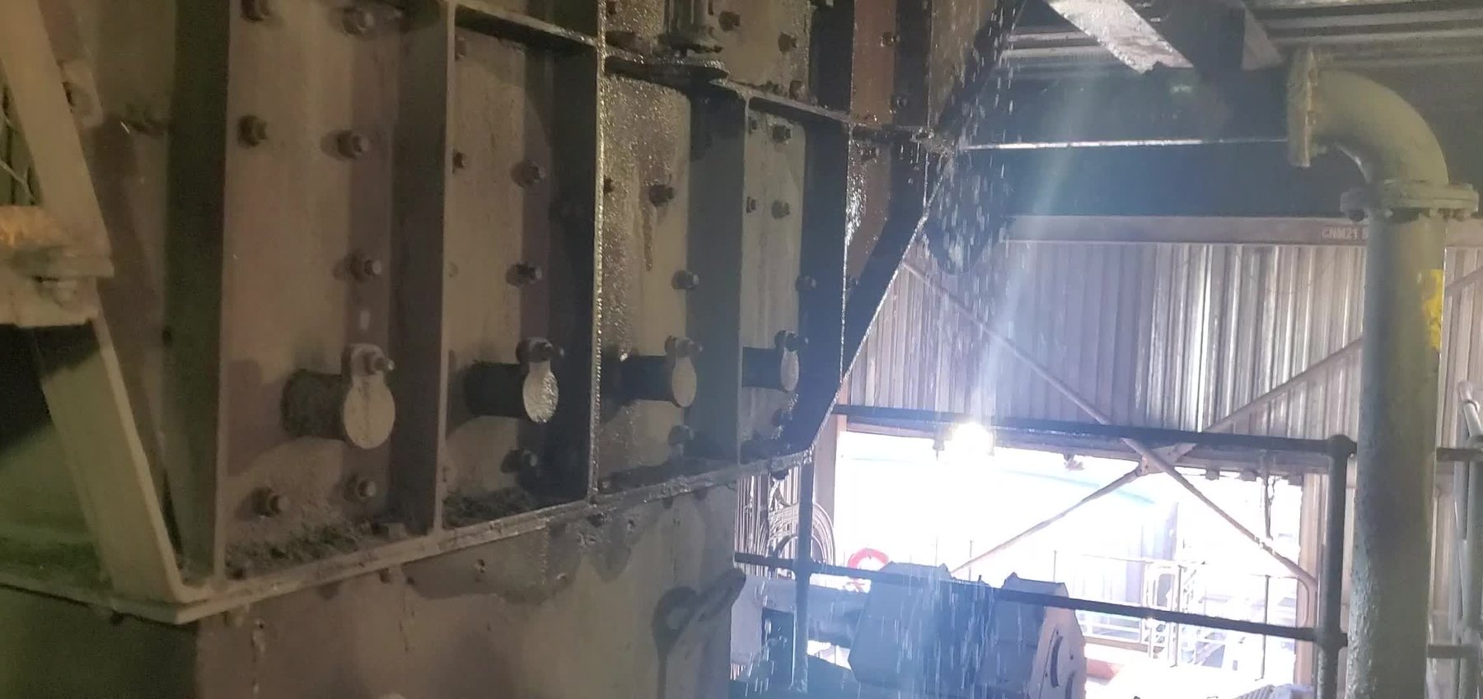  Screen-REF-016 — direct operating proof of active process-water escape/spray.
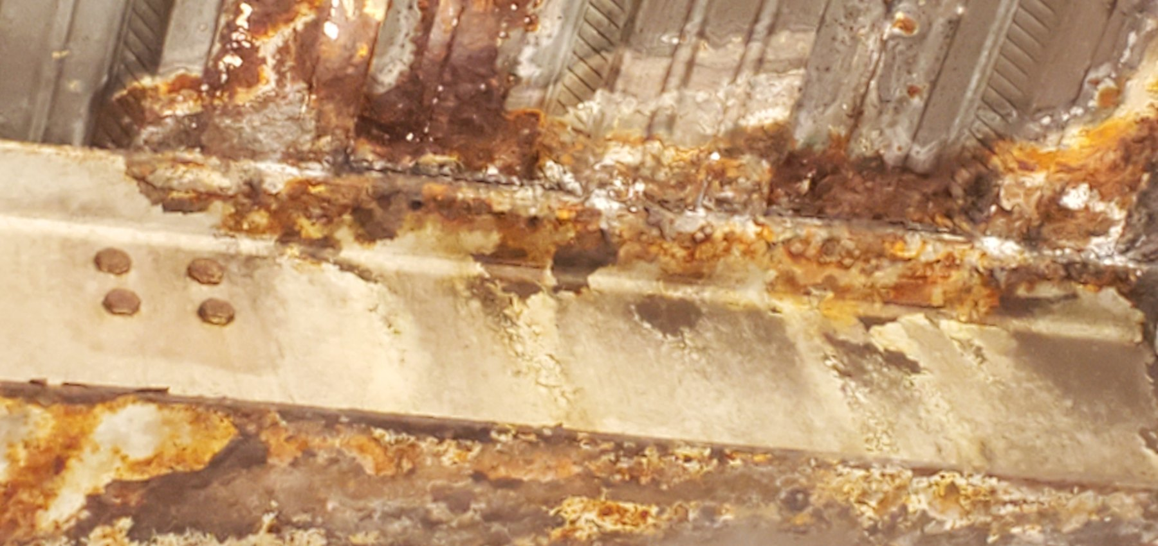  Screen-REF-004 — supporting/optional extreme corrosion close-up; current principal corrosion pair is REF-002 + REF-003, with REF-008 retained for broader severity/extent. |  | 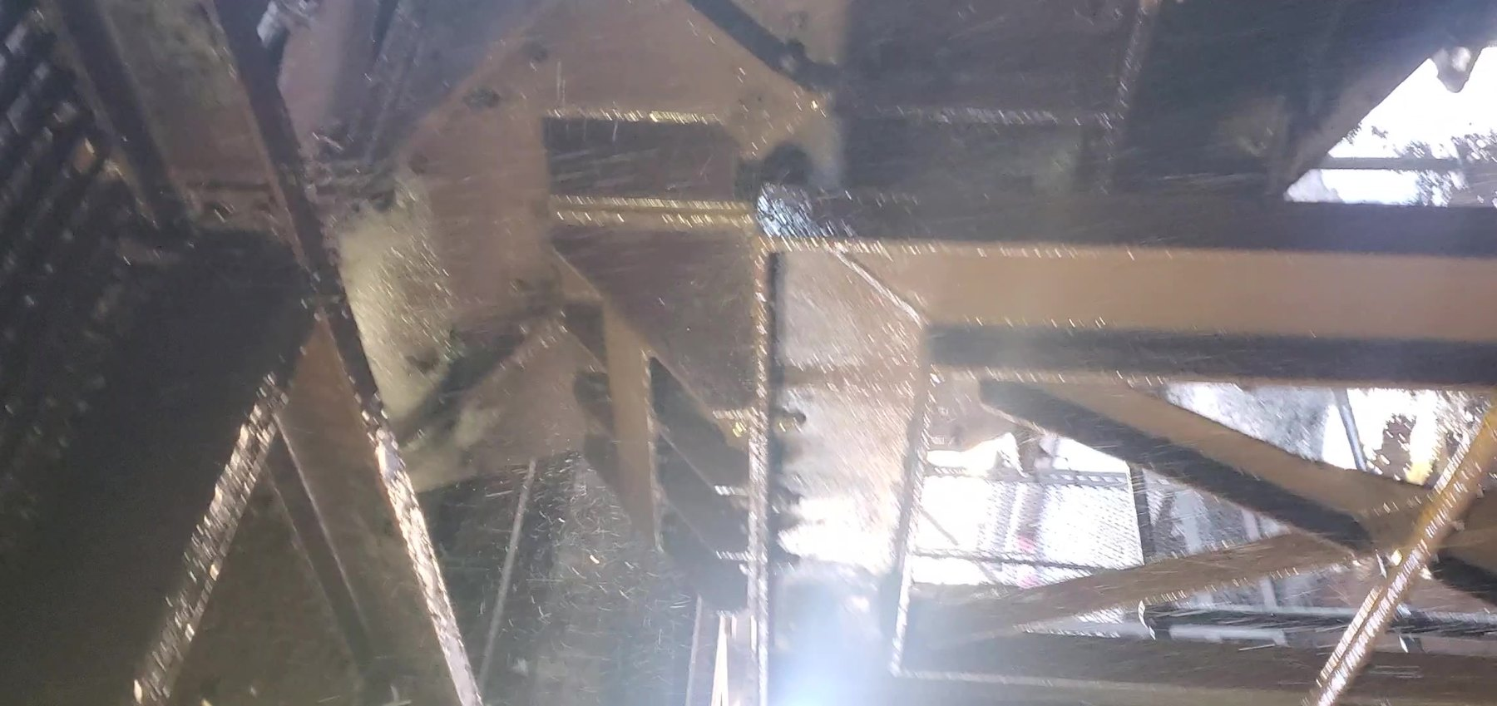  Screen-REF-017 — strongest operating evidence for localising the external point of water emergence/escape; internal source remains unresolved until shutdown inspection.
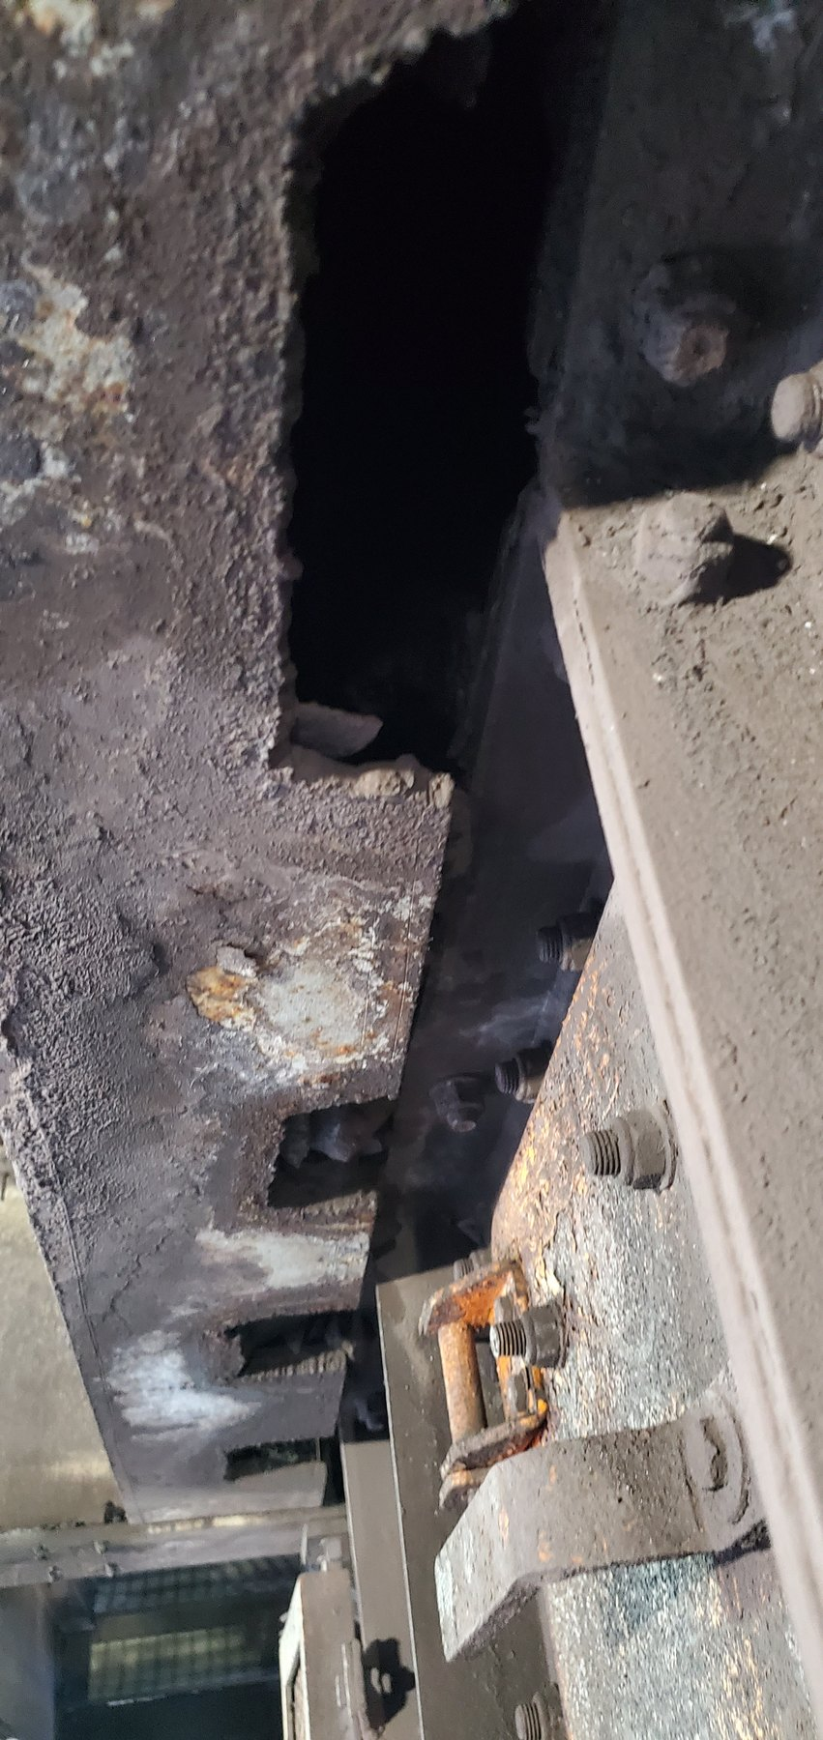  Screen-REF-006 — supporting evidence of multiple support-member cut-outs/notches; current principal structural pair is REF-009 + REF-010. |  | 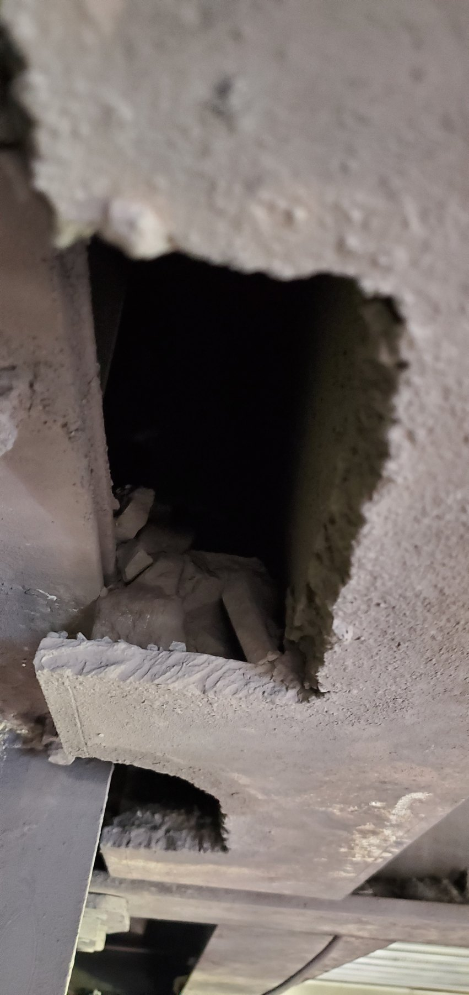  Screen-REF-010 — principal close evidence of a substantial support-member cut-out; pair with REF-009 for current body narrative.
OBSERVATION | Active water escape is directly verified. Severe corrosion/deterioration and physical support-member cut-outs/notches are also directly visible. Water, corrosion and structural alteration remain related but separate evidentiary stories.
ENGINEERING ASSESSMENT | REF-017 localises the external water emergence point but does not establish the internal defect/mechanism. Active wetting is relevant to continued exposure but is not declared the sole cause of all corrosion. The structural cuts are proven physically; motive/history and remaining capacity require competent assessment.
RECOMMENDED NEXT ACTION | Use the operating videos to mark the external escape point; perform planned shutdown/internal inspection to identify and correct the actual water-loss mechanism; re-test containment under representative operation. Separately complete competent structural assessment, engineered disposition and formal structural acceptance of the altered/deteriorated supports.

19 L1 — Spillage, Historical Belt Contact and Structural Deterioration
L1 contains several related but separate findings: extensive material/fines accumulation, concrete spalling/material loss with exposed reinforcement, severe local steel corrosion/section loss at more than one structural location, and wear slots consistent with previous/intermittent belt-to-structure contact. The accepted body evidence uses REF-004 + REF-005 for concrete deterioration, REF-008 + REF-009 for steel deterioration, REF-007 for historical belt contact, and REF-013 + REF-017 for accumulation/environmental context.
The latest inspected running condition showed the belt clear of the affected supports with no visible lateral offset/mistracking/contact. The earlier dynamic condition that produced the wear was not witnessed and remains unresolved. L1 therefore requires three coordinated workstreams: competent structural assessment and engineered repair/acceptance; measurement of the wear/contact geometry plus representative belt-tracking/clearance verification; and recurrence control to reduce product/fines/moisture accumulation around repaired structural interfaces. The report does not infer remaining capacity or a specific structural repair from photographs.
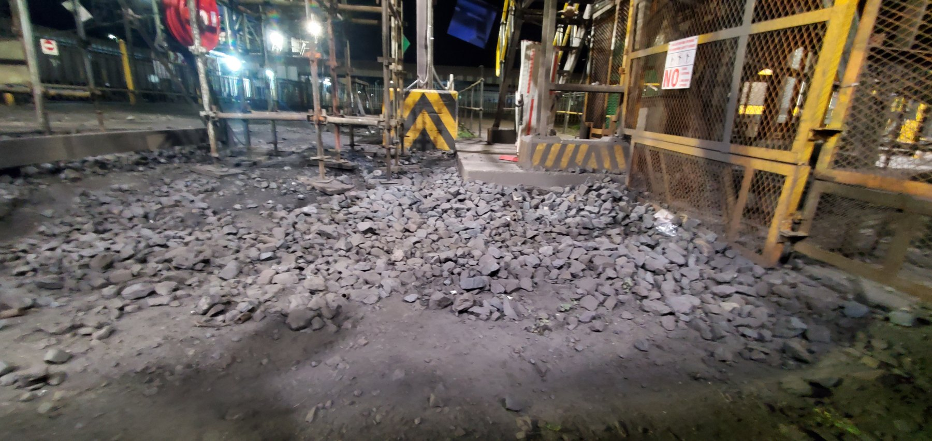
LoadoutStationL1-REF-013 — principal evidence of extensive long-term material/fines accumulation along the L1 conveyor zone.
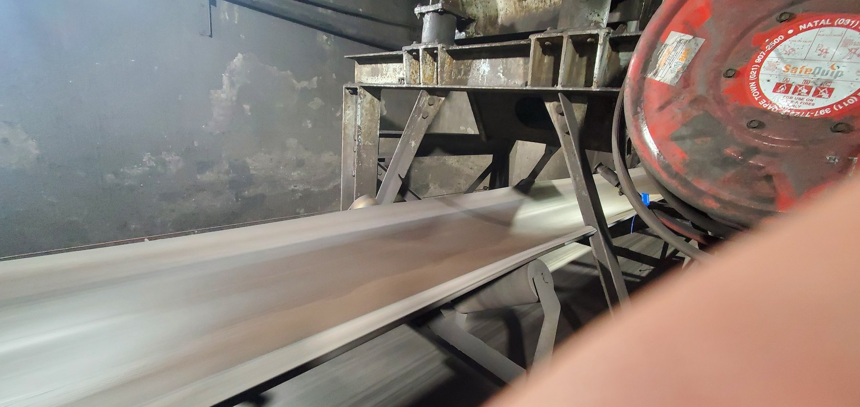  LoadoutStationL1-REF-007 — historical wear slots beside a currently clear running belt; establishes prior/intermittent contact without proving continuous present contact. | 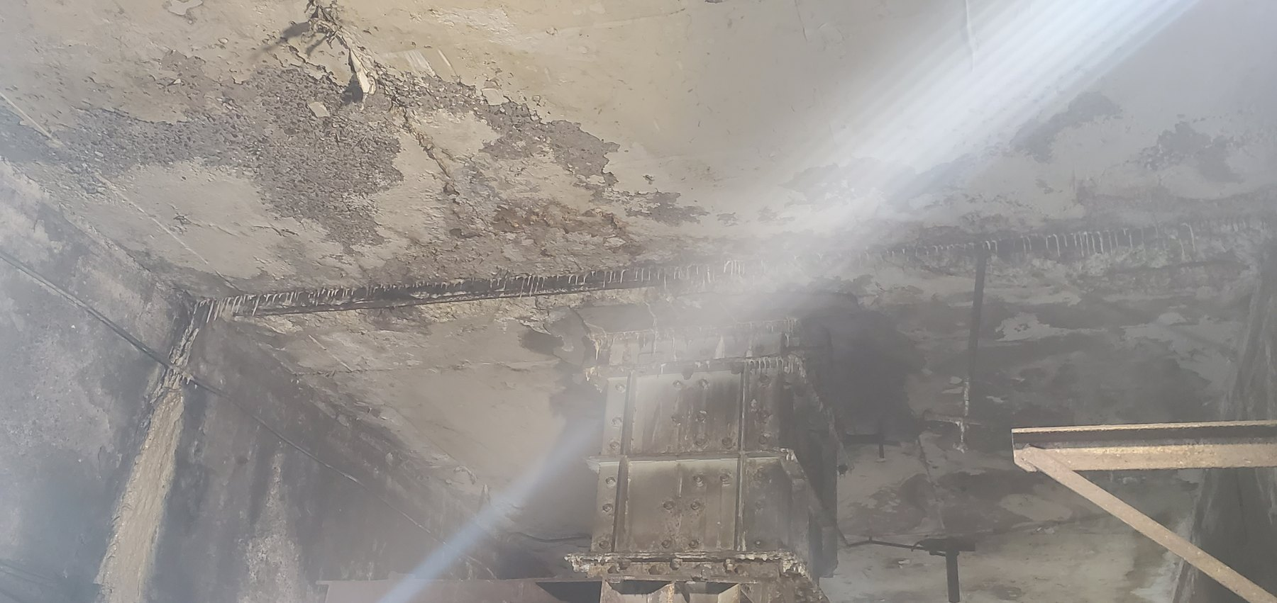  LoadoutStationL1-REF-004 — location/context for concrete deterioration. | 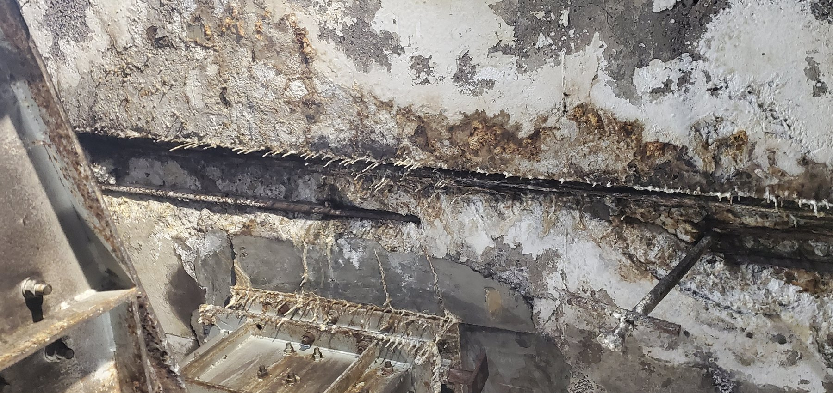  LoadoutStationL1-REF-005 — close severity of concrete loss and exposed reinforcement.
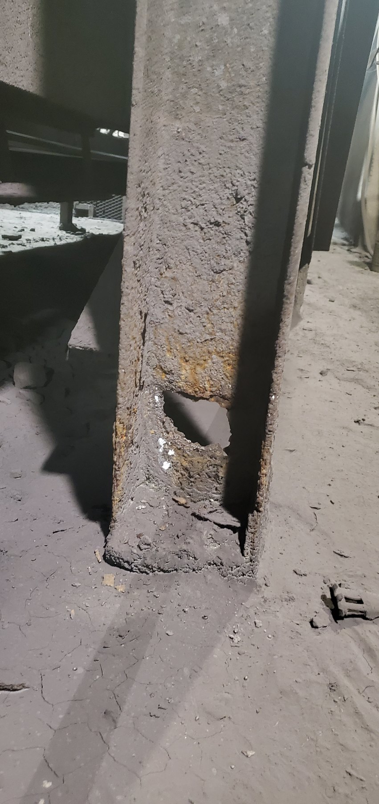  LoadoutStationL1-REF-008 — severe steel deterioration at one conveyor support location. | 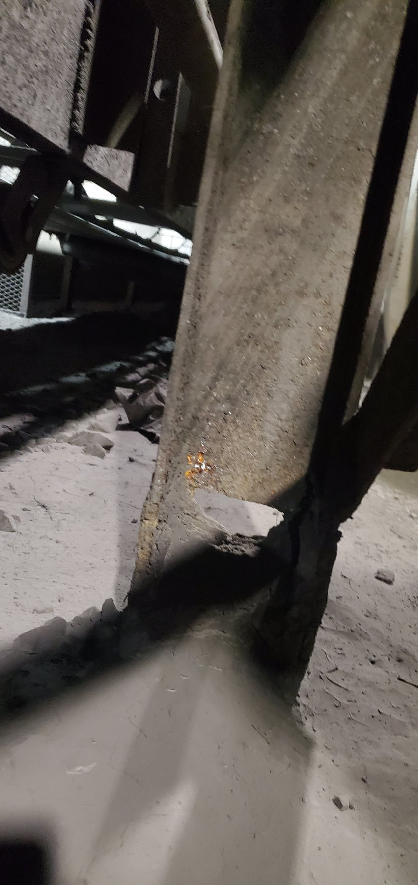  LoadoutStationL1-REF-009 — deterioration at a separate adjacent support location. | CURRENT ACCUMULATION / ENVIRONMENT CONTROL  Principal body context is REF-013 + REF-017. REF-012 is now Appendix/reference because it is redundant once the wider and elevated accumulation context is used.
OBSERVATION | Extensive accumulation, concrete deterioration/exposed reinforcement, severe local steel section loss at multiple locations and historical/intermittent belt-contact wear are directly supported. Latest operating observation showed the belt clear with no visible offset/mistracking/contact.
ENGINEERING ASSESSMENT | The wear slots establish previous/intermittent contact but not a present continuous rubbing condition or its historical cause. Structural photographs do not establish remaining capacity. The accumulation/moisture environment is relevant to recurrence but does not prove the cause of every structural defect.
RECOMMENDED NEXT ACTION | Complete competent structural assessment and approved repair/acceptance; document wear/contact geometry; verify representative belt tracking/clearance and correct any demonstrated current mechanical contributor; reduce recurring product/fines/moisture retention around repaired interfaces and monitor the as-left condition.
PART VIII — EVENT-DRIVEN AND OPERATIONAL SPILLAGE

20 Trips, Restart and Manual Product Removal
Not all material beside a conveyor is necessarily chronic mechanical spillage. Trips, blockages or related operating events can occur intermittently. Where a conveyor remains heavily loaded and the retained load hinders restart, some product may be manually removed from the belt to reduce restart load. To the best of the inspector’s knowledge, product removed for this purpose is expected to be manually returned to the conveyor/process during cleanup. The audit did not review the mine’s formal internal trip/restart procedure and does not establish that this event occurs regularly.
The report-level requirement is therefore to distinguish event-driven product removal from chronic source-generated loss and to confirm South32’s applicable procedure: when removal is authorised, isolation/access/restart controls, authorised responsibility, controlled temporary handling/placement, approved recovery/reintroduction method and the basis for distinguishing an event deposit from recurring spillage. The audit does not invent thresholds, roles or laydown arrangements.

21 Housekeeping — Necessary but Not the Primary Solution
Housekeeping remains necessary to maintain safe access, recover material and restore operating condition after accumulation or unavoidable events. It is, however, a consequence-control activity rather than a substitute for correcting a recurring source mechanism. Manual shovelling and wheelbarrow-based removal were reported as methods used in some areas but were not directly witnessed during the audit. Recovered solid product is understood to be generally intended for return to the conveyor/process where practicable, although a universal approved destination was not established.
CONTROL PRINCIPLE | Housekeeping controls the consequence. Source control should reduce the recurrence.
No single fixed housekeeping frequency was established across all inspected areas: some areas appeared to receive relatively regular cleaning while others appeared to be cleared when accumulation became significant enough to require intervention. Water wash-down was source-recorded in some areas, but the receiving route is not universally known. The Screens building has a local collection sump intended to receive at least some cleanup water and fines/slurry; that local feature must not be generalised to the wider surface plant. Area responsibility, scheduled frequency and/or condition-based trigger, approved recovery route and wash-down receiving route should therefore be confirmed locally. A clean area immediately after housekeeping is not proof that the initiating source has been corrected.
PART IX — WHAT THE COMBINED EVIDENCE MEANS

22 Consolidated Engineering Interpretation
Taken together, the evidence does not support the idea of one mine-wide spillage defect. It indicates a connected material- and process-containment problem expressed through several different mechanisms. One common objective can therefore be applied across the system while the physical correction remains specific to the mechanism, evidence strength and local geometry.
Level | Mechanism / condition | Engineering meaning
Systemic / recurring | Fines carryback; variable cleaner condition/effectiveness; incomplete containment of removed fines at some discharges. | Primary opportunity is source control at relevant discharge/cleaner locations rather than repeated downstream cleanup.
Local / geometry-specific | W10 lateral coarse/mixed transit loss; Sample 2/3 feed/product-size/loading/tracking interactions; U4 mistracking with one-sided consequence; L3 alignment concern with separate fines story. | Requires location-specific feed, tracking, geometry and residual-containment verification rather than one universal hardware solution.
Water / structural | Confirmed Screens water escape; CV01/CV04 wet conditions; Screens and L1 structural deterioration. | Water containment and structural integrity require dedicated inspection/assessment and should not be treated as housekeeping only.
Operational | Possible trip/restart off-loading and area-specific housekeeping/recovery. | Confirm governance, controlled recovery/reintroduction and area-specific housekeeping routes/frequency; keep these controls separate from source-mechanism correction.
The strongest recurring system themes are fines/carryback, variable cleaner condition/effectiveness and incomplete containment of cleaner-removed material at some discharges. Local mechanisms include W10 lateral coarse/mixed-product escape, Sample Conveyor feed/product-size/loading/tracking interactions, U4 mistracking with a one-sided coarse-product consequence, and an L3 alignment concern without the same proven coarse-product causal chain. The Screens require separate water-source and structural workstreams; L1 requires structural and historical-contact/clearance workstreams; and trip/restart handling and housekeeping remain supporting operational controls rather than one common mechanical cause.
The most important systems insight remains that the visible deposit location may be a consequence location rather than the initiating cause location. The recommended programme is therefore organised around the material-control function and mechanism supported by evidence: establish the actual loss mechanism, verify the relevant geometry/operating condition, correct primary contributors, retain product/water inside the intended process, add residual containment only where required, and prove the result under representative operation.
PART X — THE ENGINEERING CONTROL PHILOSOPHY

23 Engineering Control Philosophy — Keep the Combined Product Inside the Process
CORE PRINCIPLE | Keep the combined product — fines and coarse/lump ore — within the intended material-handling path throughout transit, and keep process water within the screening and processing systems where it is intended to remain, using controls appropriate to the specific failure mechanism and local geometry.

23.1 Fines / Carryback
- Remove residual fines effectively at appropriate discharge locations.
- Maintain cleaner contact and the required adjustment/wear-compensation function through service.
- Keep cleaner-removed fines within the intended chute/process stream.
- Prove the functional philosophy at CV09, then assess wider applicability by function and local geometry.

23.2 Coarse / Lump Product
- Verify feed quantity/variation, representative product-size distribution and loading position/trajectory relative to usable carrying geometry.
- Maintain suitable belt centring/tracking and usable carrying margin; quantify and correct demonstrated mechanical contributors.
- Where a genuine residual lateral-containment duty remains, use belt-compatible side skirting/spill sealing at the carrying edge rather than a remote external barrier.
- Verify any skirt/seal arrangement for belt-friendly contact/clearance, tracking accommodation, product trapping, wear, clean-out and maintenance access under representative operation.

23.3 Transfer Points and Process Water
- Keep transfer material within the chute/process path and correct confirmed source contributors before adding secondary controls.
- Retain process water within the screening/washing process and correct the actual verified escape mechanism after safe shutdown investigation.

23.4 Operational Events
- Where product must be removed to facilitate restart after a trip/blockage, keep it under controlled temporary handling and recover/reintroduce it through the approved process route.
- Confirm the applicable South32 procedure, authorised responsibilities, isolation/restart controls and approved recovery/reintroduction method.
- Keep event-driven deposits distinguishable from chronic source-generated spillage; use housekeeping as consequence control and performance feedback, not proof of source correction.
A practical control sequence is: establish the actual loss mechanism → verify the relevant operating condition/geometry → correct primary source/contributor → provide the required process routing/primary containment → add residual containment only where needed → recover consequences safely → confirm representative operating performance and retain an as-left/monitoring record.
PART XI — RECOMMENDED ACTION PROGRAMME

24 Programme Structure and Implementation Principle
The recommended programme follows the control hierarchy established in Part X. Its purpose is to convert the audit findings into practical work that can be verified, implemented and checked in operation. The priorities are to prove the cleaner/fines-control function at CV09 and restore CV06; correct/verify local feed, tracking and containment mechanisms; resolve Screens water and structural issues and L1 structural/clearance issues; extend proven functional controls only where locally applicable; and confirm trip/restart and housekeeping governance as supporting controls. Conceptual arrangements remain subject to verified site geometry and the appropriate South32, OEM, responsible-engineer or competent-authority review.

24.1 Priority 1A — Prove the Cleaner / Fines-Containment Function at CV09
Engineering objective: demonstrate a practical cleaner-and-containment arrangement that materially reduces downstream carryback and removes residual fines before the return run while keeping cleaner-removed material inside the existing head/discharge-chute product flow.

Required action sequence
1. Establish the as-found baseline: record current cleaner arrangement/contact, head-pulley/chute geometry, access/guarding, downstream carryback and representative wet/dry operating condition.
2. Develop the detailed design from verified site geometry using the locked functional concept: pulley-supported cleaning inside the head/discharge chute, preferred two stages where feasible, full-width effective cleaning, guided wear compensation/self-tensioning, positive travel limitation and practical maintenance access.
3. Complete OEM/responsible-engineer selection and design of the final cleaner type, materials, forces, supports/slots, structural attachments, guarding, dimensions and tolerances; install and commission under the applicable controls.
4. Monitor representative operation for an agreed period and compare downstream carryback, retained discharge flow, cleaner contact/wear behaviour and maintenance/access condition with the pre-trial baseline before wider rollout is considered.

Functional acceptance / close-out criteria
- Downstream carryback materially reduced relative to the pre-trial condition.
- Cleaner-removed wet and dry residual fines retained inside the existing head/discharge-chute process flow.
- Stable cleaner contact/function maintained through the agreed wear/operating condition without unacceptable belt damage or abnormal cleaner wear.
- Inspection, adjustment and wear-element replacement remain practical; no unacceptable guarding, trapping or access conflict is introduced.
- Monitoring record is sufficient for a defensible wider-applicability decision based on function and local geometry.
Evidence traceability: CV09-REF-002, CV09-REF-003, video CV09-REF-006; CV09-REF-008 supplementary. Figure control: CTD-005 + CTD-006. The audit defines the required cleaner function; final make/model, component materials, angles, forces/spring rates, supports, slots, attachments, wear/travel limits, guarding and fabrication details remain OEM/responsible detailed-design responsibilities.

24.2 Priority 1B — Restore and Verify CV06 Cleaner Function
Engineering objective: restore the directly compromised CV06 cleaner function and verify a complete, mechanically supported and maintainable operating arrangement. The probable housing-design/maintenance contribution should be investigated without treating it as a visually proven root cause.
1. Inspect the full cleaner assembly/support arrangement and document the housing, displaced bush/insert, cross-shaft/support, blade coverage and adjustment/retention condition.
2. Restore/replace defective or missing components through the applicable maintenance/OEM process and investigate the displacement/blade-loss history where reliable records permit.
3. Verify blade coverage/contact, support integrity, retention and adjustment after restoration, then observe representative operating performance before close-out.
Close-out: support defect corrected; required blade elements present across the intended working width; cleaner support/contact/adjustment function verified; representative operating condition recorded; any residual carryback or maintenance issue dispositioned. CV09 remains the preferred proof location for the improved functional cleaner standard.

25 Priority 2 — Correct or Verify Local Material-Loss / Alignment Mechanisms
Priority 2 addresses the local material-loss and alignment conditions that are either confirmed or sufficiently supported to justify targeted measurement and corrective work. The evidence boundary is retained at locations such as L3, where the alignment concern is supported but significant solid-product loss has not been established as a direct consequence.

25.1 U4 Tripper Car — Tracking / Alignment Correction
Objective: restore and maintain an acceptable centred belt relationship through the full normal tripper operating travel so the observed one-sided coarse-product loss is materially reduced or otherwise explained by a remaining verified mechanism, while the separate fines condition is assessed independently.
1. Document/quantify the as-found belt position and relevant tail-pulley/alignment relationship using fixed repeatable references.
2. Inspect the applicable tail pulley, carrying/return idlers, tension/training arrangement, tripper structural geometry and local interference/product accumulation; identify and correct confirmed mechanical contributors rather than merely repositioning the belt.
3. Verify acceptable centred tracking throughout normal tripper travel under representative loading/operation and retain the as-left geometry/reference record; then reassess one-sided coarse-product loss and the separate fines/carryback condition.
Close-out: acceptable centred relationship maintained through normal tripper travel under representative operation; previously observed one-sided coarse-product loss materially reduced or otherwise explained by a remaining verified mechanism; separate fines condition dispositioned; U4-specific cleaner arrangement reviewed independently of automatic CV09 replication. Evidence story: REF-008 → REF-009 → REF-004 → REF-007; fines pair REF-005 + REF-006.

25.2 Sample Conveyor 3 — Feed, Tracking and Secondary Containment
Objective: reduce coarse/mixed-product loss by treating feed quantity/variation, product-size distribution, loading position, usable carrying geometry and tracking as an interacting system before final side containment is selected.
1. Establish intended/design duty where available; document representative feed quantity/variation, product-size distribution and loading position/trajectory relative to the narrow carrying geometry.
2. Quantify the visually substantial lateral offset using fixed references; inspect alignment, tension/training, interference and entry-zone conditions; correct confirmed primary contributors and prove acceptable centred operation under representative loading.
3. Reassess feed/product/loading controls and corrected usable carrying geometry; then define and install/adapt belt-compatible side skirting/spill sealing only for verified residual duty.
Close-out: design/feed/product/loading basis sufficiently documented; lateral offset quantified and confirmed contributors corrected/dispositioned; acceptable centred operation demonstrated; coarse/mixed loss materially reduced; any residual skirt/seal is belt-compatible and maintainable. Evidence: REF-002, REF-003, REF-004, REF-005, principal offset pair REF-006 + REF-007, consequence REF-012. REF-013 withdrawn and not usable.

25.3 Sample Conveyor 2 — Feed / Loading Verification Before Secondary Containment
Objective: establish the interaction between feed quantity/variation, product size, loading position and usable carrying geometry; quantify the captured lateral-offset condition without assuming a root cause; and determine residual containment only after primary contributors are addressed.
1. Establish intended duty and actual feed-control/metering arrangement; document representative feed/product-size distribution, loading trajectory/centring and usable belt geometry.
2. Quantify live belt position/tracking and inspect the congested entry/guide interaction zone; correct confirmed feed/loading/alignment/tracking/interference contributors and prove acceptable centred operation.
3. Reassess the corrected carrying geometry and remaining feed/product controls; define/install belt-compatible side skirting/spill sealing only where a genuine residual containment duty remains, then verify representative performance.
Close-out: feed/product/loading/geometry relationship documented; captured offset quantified and confirmed cause(s) corrected/dispositioned; centred operation verified; visible loss materially reduced; any residual skirt/seal maintains belt-friendly operation and access. Evidence reasoning: REF-004 + REF-001 opening pair; REF-004 + REF-005 product-size/offset pair; REF-007 loading/product context; REF-006 congestion/interaction.

25.4 W10 — Source-Control Review and Side-Containment Feasibility
Objective: keep coarse/mixed product on the W10 belt and reduce migration into the restricted tunnel by correcting confirmed primary contributors and using belt-edge side skirting/spill sealing for residual lateral containment; the tunnel access consequence is context, not the design objective.
1. Record representative belt/trough/support geometry and belt position/tracking; inspect loading/feed-distribution and other likely source contributors.
2. Correct confirmed primary loading/tracking/geometry contributors where practicable and establish the genuine residual lateral-containment duty.
3. Where residual duty remains, develop/install flexible belt-compatible side skirting/spill sealing on the inside of the carrying width, with the lower seal relationship, extent, support and wear adjustment determined by the selected OEM system.
Close-out: primary contributors investigated/corrected where verified; skirt/seal function retains product on the belt; no unacceptable rubbing/gouging, trapping, inaccessible build-up, wear or maintenance/access problem introduced; representative tunnel accumulation materially reduced. Figure control: CTD-010 + CTD-011. Evidence: W10-REF-002/-010 with supporting -006/-009.

25.5 L3 — Quantitative Alignment / Tracking Verification
Objective: quantify and correct the supported L3 tail-end alignment/tracking condition where required while preserving the evidence boundary that significant coarse/lump-product loss is not established as a direct consequence.
1. Establish fixed references and measure the tail-end belt/pulley/support relationship; inspect applicable idler/alignment/tension/training/interference contributors and observe representative live tracking.
2. Correct any verified alignment/tracking defect and retain as-left geometry/operating belt position; reassess fines/material accumulation separately without converting the alignment finding into an unsupported coarse-product causal claim.
Close-out: geometry quantitatively established; confirmed defect corrected/dispositioned; stable/acceptable live tracking recorded; as-left references retained; fines condition reviewed separately; causal qualification maintained. Evidence: alignment REF-001; fines REF-002 + REF-004 + REF-007; supporting lower-area REF-008.

26 Priority 3 — Water Containment and Structural Actions
Priority 3 treats process-water containment and structural integrity as related but separate workstreams so that each can be investigated and addressed according to its own evidence and engineering requirements.

26.1 Screens — Identify the Water-Escape Mechanism Before Modification
Objective: retain process water and entrained wet fines within the screening/chute process by tracing the externally visible escape point to the actual internal source/defect during a safe shutdown, correcting that verified mechanism and proving containment after recommissioning.
1. Use Screen-REF-016/017 to localise and mark the external water-emergence point observed during operation.
2. Isolate the screen and inspect the corresponding internal area during planned shutdown; identify the first actual point/mechanism by which water leaves the intended screening/washing/chute process path and record the relevant geometry/condition.
3. Correct the verified primary defect/mechanism and confirm the intended process-water/drainage route; recommission and re-check the previously identified external location under representative operation.
Close-out: internal escape mechanism documented; corrective work addresses the verified mechanism; process-water containment demonstrated at the previously observed location during representative operation; surrounding repeatedly wetted equipment/steelwork inspected separately. Evidence: Screen-REF-016 direct escape; Screen-REF-017 external localisation. Do not prescribe a generic chute/drainage modification before the mechanism is established.

26.2 Screens — Structural Support Assessment
Objective: establish the structural role, current condition and remaining adequacy of the cut/notched/corroded screen-support members and obtain an engineered disposition without assuming why the historical alterations were made.
1. Appoint a competent structural authority; identify affected members/load paths and record member dimensions, cut/notch/opening geometry, corrosion/section loss, connections and relevant deformation/deterioration.
2. Review available modification/maintenance/equipment-replacement records without assuming motive; determine current adequacy/capacity and any required interim controls; develop and implement the approved repair/strengthening/replacement/reinstatement response.
Close-out: competent structural assessment complete; modification history recorded where available; remaining adequacy and required controls defined; approved intervention implemented/controlled; final as-left inspection and formal structural acceptance completed. The audit does not specify plates, welds, member sections, allowable loads or fabrication details. Principal structural evidence: REF-009 + REF-010; REF-006 supporting. Corrosion: REF-002 + REF-003, with REF-004 supporting and REF-008 retained for extent.

26.3 L1 — Structural Condition and Belt-Clearance Verification
Objective: address the documented L1 structural deterioration, verify the historical belt-contact/clearance condition under representative operation and reduce recurring product/fines/moisture retention around repaired interfaces, while keeping the mechanisms evidentially separate.
1. Complete competent structural assessment of affected concrete, exposed reinforcement, steel members, supports and connections; record concrete loss, steel section loss/perforation and required repair-design inputs; define any interim controls and approved structural disposition.
2. Record wear-slot/contact geometry and relevant belt-to-structure clearance; observe representative belt tracking/clearance. Correct a current mechanical contributor only if it is demonstrated; otherwise retain the historical-contact qualification.
3. Implement the approved structural repair/rehabilitation and formal as-left acceptance; reduce recurring product/fines/moisture accumulation around repaired interfaces and include the local condition in follow-up monitoring.
Close-out: structural adequacy assessed and approved disposition implemented/controlled; representative belt clearance/tracking acceptable; no unsupported claim of current continuous contact; accumulation/moisture recurrence addressed as a separate environmental control. Evidence: concrete REF-004 + REF-005; steel REF-008 + REF-009; historical contact REF-007; environment REF-013 + REF-017. REF-012 appendix/reference.

27 Priority 4 — Extend Proven Controls Where Applicable
Once the CV09 pilot and targeted local corrections have demonstrated satisfactory representative performance, the same functional requirements can be assessed at other relevant locations. Wider rollout should be based on the mechanism, local geometry, material condition, maintenance/access requirements and observed post-intervention performance rather than automatic duplication of the same hardware. Cleaner presence/configuration remains unverified at several locations; U4 remains an explicit geometry-specific exception.
A successful result at one location should therefore trigger a structured applicability review. For cleaner/fines control, compare pulley-supported cleaning opportunity, effective stage count, blade coverage/contact, wear compensation/self-tensioning, positive travel limitation, component retention, containment of removed material, maintainability and actual downstream carryback. For side containment, verify local feed/loading/tracking geometry and residual duty before selecting a skirt/seal arrangement.

28 Priority 5 — Operational and Housekeeping Governance
Operational and housekeeping controls remain necessary for event-driven deposits, safe access, recovery and performance feedback. They support — but do not replace — source correction. Because this audit did not review the mine’s complete formal procedures, V0.6 defines the required control function and the information South32 should confirm rather than inventing site roles, thresholds, fixed frequencies or universal recovery routes.

28.1 Trip / Restart Product Handling
Confirm the applicable written trip/restart/belt-clearing procedure, including when product removal is authorised, isolation/access/restart controls, authorised responsibility, controlled temporary handling/placement, approved recovery/reintroduction method and how event-driven deposits are distinguished from chronic source-generated spillage. The source-recorded understanding is that off-loading may be used intermittently to reduce retained belt load where restart is hindered, and removed product is expected to be returned to the conveyor/process during cleanup where practicable.
Close-out: approved procedure and responsibilities confirmed; temporary handling/recovery route defined; event-driven deposits distinguishable in operating history where practicable; no audit-invented threshold or laydown arrangement presented as South32 procedure.

28.2 Housekeeping / Recovery
Confirm area-specific housekeeping responsibility, scheduled frequency and/or condition-based trigger, approved solid-product recovery/reintroduction route and — where wash-down is used — the receiving drainage/process route. Manual shovelling/wheelbarrow use was reported but not witnessed. The Screens building local sump may form part of that area’s cleanup-water/fines recovery subject to confirmation; it is not evidence of a universal plant-wide recovery system. Retain repeat-accumulation records where useful for source-control performance feedback and keep housekeeping-task closure separate from source-mechanism closure.
Governing principle: Housekeeping controls the consequence. Source control should reduce the recurrence. A clean area immediately after housekeeping is not evidence that the initiating spillage mechanism has been corrected.

28.3 Programme Close-Out Rule
Each material action should retain the evidence chain: as-found evidence → verification/measurement → corrective design or control → implementation → representative operating proof → as-left record → monitoring/closure. Maintenance sign-off, installation completion or a cleaned area is an intermediate milestone unless the intended functional outcome is also demonstrated.

28.4 Consolidated Priority Action Register
Priority | Action | Type | Verification / design requirement | Primary evidence / case
1A | CV09 pulley-supported cleaner + inside-chute containment pilot | Design development / pilot | As-found geometry; preferred two-stage / constrained one-stage minimum; self-tensioning/wear stop; inside-chute discharge retention; representative monitoring | CV09
1B | CV06 cleaner restoration | Maintenance / operating verification | Restore support/blades; verify contact/coverage/support; operating check | CV06
2 | U4 tracking/alignment correction | Corrective maintenance + verification | Quantify as-found relationship; correct verified contributors; prove centred tracking through normal tripper travel; separate coarse/fines outcomes | U4
2 | Sample Conveyor 3 design/feed/loading/tracking/containment | Process / mechanical design | Design/feed/product/loading basis; quantify/correct REF-006/007 offset; residual belt-edge skirting only after primary correction | Sample 3
2 | Sample Conveyor 2 design/feed/loading/tracking verification | Process verification | Design/feed/product/loading basis; quantify captured REF-004/005 offset; inspect congestion; residual skirting only after primary correction | Sample 2
2 | W10 source review + side-skirt/spill-seal containment | Engineering verification / concept | Loading/tracking/geometry source review; correct primary contributors; define residual belt-edge skirting duty; representative operation/access/wear check | W10
2 | L3 alignment/tracking verification | Mechanical verification | Quantify tail-end geometry; live tracking; correct/disposition; retain causal qualification | L3
3 | Screens water escape investigation | Shutdown inspection / design input | Use REF-016/017 to localise external escape; planned shutdown internal mechanism record; correct verified defect; post-mod operating proof | Screens
3 | Screens structural assessment | Structural | Member/load-path identification; cuts/notches/section loss/connections; competent capacity/repair disposition; formal as-left acceptance | Screens
3 | L1 structural + clearance verification | Structural / mechanical | Concrete/steel capacity and repair; wear/contact geometry; representative no-contact/tracking verification; reduce recurring accumulation/moisture | L1
5 | Trip/restart governance | Operational | Confirm formal procedure, authorisation, isolation/restart controls, controlled temporary handling and approved recovery/reintroduction route | System-wide
5 | Housekeeping / recovery governance | Operational | Area responsibility/frequency or trigger; approved recovery/reintroduction route; wash-down receiving route where used; repeat-accumulation feedback | System-wide / area-specific
PART XII — CONCLUSION

29 Conclusion
The Combined Product Spillage Audit indicates that spillage across the inspected Wessels Mine material-handling route is not the result of one isolated defect. Taken together, the findings show a broader material- and process-containment problem expressed through several different mechanisms at different locations.
Recurring fines/carryback is the strongest system-wide pattern. CV06 provides a clear example of compromised cleaner mechanical integrity, while CV09 demonstrates that removing material from the belt is only part of the control function: the cleaner must act effectively and the removed fines must remain inside the discharge process. The preferred CV09 pilot therefore places pulley-supported cleaner stages inside the head/discharge chute, with controlled wear compensation/self-tensioning and positive travel limitation, so removed fines fall naturally into the existing combined-product discharge flow.
Coarse or mixed-product loss at W10 and the Sample Conveyors requires a different response focused on usable carrying geometry. W10’s accepted residual control is belt-edge side skirting/spill sealing, not an external walkway barrier. Sample Conveyors 2 and 3 require the interaction of feed quantity/variation, product-size distribution, loading position, usable belt geometry and tracking to be verified; captured lateral offset is supported at both locations, with Sample 3 visually substantial but unmeasured. U4 provides the clearest local tracking-to-one-sided coarse-product relationship, while L3 remains an alignment concern without an equivalent proven significant coarse-product causal chain.
At the Screens, active process-water escape is directly verified. The videos can localise the external emergence point, but the internal defect/mechanism must be established during planned shutdown before detailed modification is specified. Severe corrosion/deterioration and cut/notched support members form a separate structural workstream requiring competent assessment and engineered disposition. L1 similarly combines extensive accumulation, concrete and steel deterioration, and historical/intermittent belt-contact wear; the latest inspected running condition showed the belt clear with no visible mistracking/contact, so structural and mechanical conclusions remain properly separated.
The audit also distinguishes recurring source-generated spillage from product that may be deliberately removed during a trip, blockage or restart intervention. Such material still requires controlled temporary handling and approved recovery/reintroduction, but its presence beside a conveyor should not automatically be interpreted as chronic mechanical failure at that location. Housekeeping remains necessary consequence control; some methods and frequencies were source-recorded, but area-specific procedure, recovery route and wash-down receiving route should be confirmed rather than assumed.
Across all mechanisms, the common engineering objective is to keep combined product within the intended material-handling/process path and retain process water within its intended process route, using controls appropriate to the actual mechanism and local geometry. The report therefore does not recommend one identical cleaner, skirt or mechanical modification throughout the system. What can be standardised is the required engineering function, the evidence/measurement used to justify it and the representative operating proof used to close it out.
The recommended programme combines practical corrective work with the measurement, detailed-design and operating checks needed to confirm that each action has achieved its intended purpose. Items that remain open — such as exact site geometry, quantified tracking, structural capacity, the internal Screens water defect, final OEM component detail, formal operational procedures and representative as-left performance — are verification/design/governance matters rather than unresolved report-level solution concepts.
The ultimate objective is not simply a cleaner plant floor. It is a material-handling system in which product and process water remain controlled through the intended process, recurring loss mechanisms are corrected at source where practicable, residual containment is applied deliberately where required, and the effectiveness of each intervention is demonstrated and sustained in operation.
FINAL TAKEAWAY | The goal is not simply a cleaner plant floor. It is a material-handling system in which the product and process water remain controlled through the intended process and where unavoidable losses or interventions are contained, recoverable and deliberately managed.

30 Technical Review and Report Issue Sign-off
This V0.6 document is the Stage-B integrated controlled revision of the V0.5 terminology-refined draft and remains NOT FOR ISSUE. It reconciles the accepted V0.2-derived report architecture and softer engineering voice with source-reconciled Context V4.3, the Stage-A gap register, current evidence overlays and the locked report-level engineering/operational concepts. It is not content freeze. Final body/appendix evidence allocation, active conceptual-figure binary placement, source/reuse confirmation for external figure material, outstanding measurements and site verification, OEM/responsible-engineer/competent-authority review, publication styling and formal issue authorisation remain open.
Role | Name | Status
Prepared by | Inspection & Specification Services cc. | V0.6 Stage-B integrated controlled draft prepared
Technical review | [TO BE COMPLETED] | Pending engineer / technical review
Client review / action alignment | [TO BE COMPLETED] | Pending
Approved for issue | [TO BE COMPLETED] | Pending

APPENDICES — TECHNICAL EVIDENCE BACKBONE

Appendix A — Full Asset-by-Asset Audit Matrix
Appendix A provides the report-facing 23-group asset audit matrix. It summarises each controlled inspection group, the strongest supported condition/mechanism, representative evidence references and the action direction. The full 197-row EVIDENCE_STORY_MATRIX_V0.1.csv remains the detailed item-level evidence source.
Area | Asset / group | Verified condition / mechanism | Key evidence | Action direction
Underground - Central Block | Underground Crusher | Mixed coarse/lump and fines accumulation; local standing water visible, source unresolved. | UGCrusher-REF-001/-002 | Investigate local material/water contributors; maintain source-control/carryback review.
Underground - Central Block | UC05-UC01 continuous system | Distributed dry fines with mixed coarse fragments; severe local mounds and clear comparator sections. | UGUC05_04_03_02_01-REF-005/-006/-007/-015 | Treat as systemic recurrence/carryback story; target discharge/cleaner source control and trending.
Underground - Secondary Plant | U3 Conveyor | Local conveyor-adjacent fines/mixed accumulation; roadway coarse rock not automatically conveyor spillage. | UGU3-REF-004/-007 | Maintain origin qualification; local inspection/source control as required.
Underground - Secondary Plant | U4 Tripper Car | Visually established lateral mistracking/offset; inspector-recorded tail-pulley/alignment concern unmeasured; one-sided coarse-product consequence plus separate fines condition. | UGU4-REF-008/-009/-004/-007; fines -005/-006; video -010 supporting | Quantify/correct alignment/tracking and prove full normal tripper travel under representative loading; reassess coarse loss and fines separately; cleaner exception reviewed locally.
Underground - Silos / Feeders | U5A Conveyor | Extensive/widespread dry fines; return-side geometry strongly consistent with carryback. | UG5A-REF-002/-004/-006 | Prioritise cleaner/discharge source-control applicability review.
Underground - Silos / Feeders | U5B Conveyor | Trace-to-localised dry fines overall with some sizeable local deposits. | UG5B-REF-001/-003/-006 | Maintain localised classification; inspect source/cleaner only as evidence warrants.
Surface - Screening / Transfer | W10 | Substantial coarse/mixed product in restricted tunnel; exact initiating cause unresolved. | W10-REF-002/-010; supporting -006/-009 | Verify loading/tracking/geometry and correct primary contributors; define residual duty and install belt-compatible side skirting/spill sealing inside carrying width if required.
Surface - Screening / Transfer | CV01 | Wet-fines/slurry and pooled water; severe visible roller surface damage; seized state not dynamically proven. | CV01-REF-001/-003 | Correct maintenance condition; investigate water/material source without overclaim.
Surface - Screening / Transfer | CV02 | Dry fines plus mixed/lump accumulation around transfer/return-side structure. | CV02-REF-001/-003 | Supporting fines/carryback/source-control review.
Surface - Screening / Transfer | CV03 | No significant spillage in inspected condition; clean comparator. | CV03-REF-002 | Retain as time-specific comparator; no escalation.
Surface - Screening / Transfer | CV04 | Saturated wet-fines/slurry and multiple piles; extensive/widespread. | CV04-REF-002/-005 | Investigate water/material source and containment; source not inferred from stills.
Surface - Screening / Transfer | CV06 | Displaced cleaner support bush/insert; scraper blades absent from working width. | CV06-REF-004/-005 | Restore and verify cleaner function; investigate history where records permit.
Surface - Screening / Transfer | CV09 | Wet fines/slurry, cleaner outside/open to effective head-chute containment, active fallout and residual downstream carryback; preferred pilot for integrated cleaner/fines containment. | CV09-REF-002/-003; video -006 | Pilot pulley-supported cleaning inside head/discharge chute; preferred two stages where feasible; self-tensioning/wear stop; representative monitoring; OEM detail design.
Surface - Screening / Transfer | CV14 | Trace/localised dry fines/carryback deposits. | CV14-REF-002 | Supporting low-severity recurrence; no escalation.
Surface - Screening / Transfer | CV15 | Extensive distributed fines/carryback around chute E-3181; stills mainly dry/dried. | CV15-REF-003/-004/-006 | Assess cleaner/discharge functionality; retain wet-condition qualification.
Surface - Screening / Transfer | Screens / screen chutes | Active process-water escape verified; severe corrosion and cut/notched supports verified; exact mechanism/capacity unresolved. | Screen-REF-016/-017 water; corrosion -002/-003 (support -004, extent -008); structural -009/-010 (support -006) | Localise external water emergence, planned shutdown internal-source verification/correction, operating proof; separate competent structural assessment and formal acceptance.
Surface - Loading Station | L1 Conveyor | Extensive spillage; severe concrete/steel deterioration; previous/intermittent belt-contact evidence. | Concrete -004/-005; steel -008/-009; historical contact -007; environment -013/-017 | Competent structural assessment/repair acceptance plus representative belt-clearance/tracking verification; reduce recurring accumulation/moisture. Latest running belt clear/no visible mistracking.
Surface - Loading Station | L2 Conveyor | No significant spillage in inspected condition; photo/video comparator. | LoadoutStationL2-REF-004.jpg / REF-005 media | Retain time-specific clean comparator; no chronic claim.
Surface - Loading Station | L3 Conveyor | Tail-end offset supported but unmeasured; fines visible; significant solid-product causal chain not established. | Alignment REF-001; fines REF-002/-004/-007; supporting -008 | Quantify alignment/live tracking; correct/disposition without overclaiming product loss.
Surface - Loading Station | L4 Conveyor | Localised dry fines and coarse/lump accumulation; operating stills generally contained. | LoadoutStationL4-REF-003/-004 | Local source/containment review as required; no active-fall claim.
Surface - Loading Station | Sample Conveyor 1 | Extensive/widespread mixed fines/coarse accumulation; adhered/dried deposits indicate sticky/moist history. | LoadoutStationSample1-REF-011/-008/-005 | Supporting system consequence/source-control review; active wetness not proven.
Surface - Loading Station | Sample Conveyor 2 | Coarse/lump product occupies substantial narrow carrying geometry; containment loss; captured lateral offset supported by REF-004/005 but magnitude/persistence/root cause unverified. | LoadoutStationSample2-REF-004/-005/-001/-007/-006 | Verify design/feed/product/loading basis; quantify/correct tracking/interference; prove centred operation; residual belt-compatible skirting only if required.
Surface - Loading Station | Sample Conveyor 3 | Substantial coarse/lump spillage and narrow carrying margin; visually substantial lateral offset supported by REF-006/007, unmeasured; root contributor unresolved. | LoadoutStationSample3-REF-002/-003/-004/-005/-006/-007/-012; REF-013 withdrawn | Verify design/feed/product/loading basis; quantify/correct tracking; prove centred operation; residual side skirting only after primary corrections. Do not use REF-013.

Appendix B — Detailed Photographic Evidence Register
Appendix B provides the controlled photographic register by asset group. The current active population contains 188 photographs and 8 videos (196 inspection media). LoadoutStationSample3-REF-013 is withdrawn from active use and is therefore not included in the 188-photo count. Current E/S/A placement priorities are governed by evidence_index_CURRENT.md and the applicable Sample Conveyor, U4/L3, Screens and L1 overlays. Repository originals remain master evidence.
Asset / group | Photos | Canonical range / naming | Principal body candidates | Control note
Underground Crusher | 5 | UGCrusher-REF-001..005 | UGCrusher-REF-001/-002 | Repository originals retained. Current body/appendix priority is governed by evidence_index_CURRENT.md and the applicable active overlay; use the smallest sufficient evidence set and preserve item-specific qualifications.
UC05-UC01 continuous system | 16 | UGUC05_04_03_02_01-REF-001..016 | UGUC05_04_03_02_01-REF-005/-006/-007/-015 | Repository originals retained. Current body/appendix priority is governed by evidence_index_CURRENT.md and the applicable active overlay; use the smallest sufficient evidence set and preserve item-specific qualifications.
U3 Conveyor | 8 | UGU3-REF-001..008 | UGU3-REF-004/-007 | Repository originals retained. Current body/appendix priority is governed by evidence_index_CURRENT.md and the applicable active overlay; use the smallest sufficient evidence set and preserve item-specific qualifications.
U4 Tripper Car | 11 | UGU4 photos: REF-001..009, -011..012 | UGU4-REF-008/-009/-004/-007; fines -005/-006; video -010 supporting | Repository originals retained. Current body/appendix priority is governed by evidence_index_CURRENT.md and the applicable active overlay; use the smallest sufficient evidence set and preserve item-specific qualifications.
U5A Conveyor | 9 | UG5A-REF-001..009 | UG5A-REF-002/-004/-006 | Repository originals retained. Current body/appendix priority is governed by evidence_index_CURRENT.md and the applicable active overlay; use the smallest sufficient evidence set and preserve item-specific qualifications.
U5B Conveyor | 6 | UG5B-REF-001..006 | UG5B-REF-001/-003/-006 | Repository originals retained. Current body/appendix priority is governed by evidence_index_CURRENT.md and the applicable active overlay; use the smallest sufficient evidence set and preserve item-specific qualifications.
W10 | 12 | W10-REF-001..012 | W10-REF-002/-010; supporting -006/-009 | Repository originals retained. Current body/appendix priority is governed by evidence_index_CURRENT.md and the applicable active overlay; use the smallest sufficient evidence set and preserve item-specific qualifications.
CV01 | 4 | CV01-REF-001..004 | CV01-REF-001/-003 | Repository originals retained. Current body/appendix priority is governed by evidence_index_CURRENT.md and the applicable active overlay; use the smallest sufficient evidence set and preserve item-specific qualifications.
CV02 | 4 | CV02-REF-001..004 | CV02-REF-001/-003 | Repository originals retained. Current body/appendix priority is governed by evidence_index_CURRENT.md and the applicable active overlay; use the smallest sufficient evidence set and preserve item-specific qualifications.
CV03 | 3 | CV03-REF-001..003 | CV03-REF-002 | Repository originals retained. Current body/appendix priority is governed by evidence_index_CURRENT.md and the applicable active overlay; use the smallest sufficient evidence set and preserve item-specific qualifications.
CV04 | 5 | CV04-REF-001..005 | CV04-REF-002/-005 | Repository originals retained. Current body/appendix priority is governed by evidence_index_CURRENT.md and the applicable active overlay; use the smallest sufficient evidence set and preserve item-specific qualifications.
CV06 | 5 | CV06-REF-001..005 | CV06-REF-004/-005 | Repository originals retained. Current body/appendix priority is governed by evidence_index_CURRENT.md and the applicable active overlay; use the smallest sufficient evidence set and preserve item-specific qualifications.
CV09 | 5 | CV09-REF-001..005 | CV09-REF-002/-003; video -006; -008 supplementary | Repository originals retained. Current body/appendix priority is governed by evidence_index_CURRENT.md and the applicable active overlay; use the smallest sufficient evidence set and preserve item-specific qualifications.
CV14 | 2 | CV14-REF-001..002 | CV14-REF-002 | Repository originals retained. Current body/appendix priority is governed by evidence_index_CURRENT.md and the applicable active overlay; use the smallest sufficient evidence set and preserve item-specific qualifications.
CV15 | 8 | CV15-REF-001..008 | CV15-REF-003/-004/-006 | Repository originals retained. Current body/appendix priority is governed by evidence_index_CURRENT.md and the applicable active overlay; use the smallest sufficient evidence set and preserve item-specific qualifications.
Screens / screen chutes | 14 | Screen-REF-001..014 | Water -016/-017; corrosion -002/-003 (support -004; extent -008); structural -009/-010 (support -006) | Repository originals retained. Current body/appendix priority is governed by evidence_index_CURRENT.md and the applicable active overlay; use the smallest sufficient evidence set and preserve item-specific qualifications.
L1 Conveyor | 18 | LoadoutStationL1-REF-001..018 | Concrete -004/-005; steel -008/-009; historical contact -007; environment -013/-017 | Repository originals retained. Current body/appendix priority is governed by evidence_index_CURRENT.md and the applicable active overlay; use the smallest sufficient evidence set and preserve item-specific qualifications.
L2 Conveyor | 6 | LoadoutStationL2-REF-001..006.jpg | LoadoutStationL2-REF-004.jpg / REF-005 media | Repository originals retained. Current body/appendix priority is governed by evidence_index_CURRENT.md and the applicable active overlay; use the smallest sufficient evidence set and preserve item-specific qualifications.
L3 Conveyor | 8 | LoadoutStationL3-REF-001..008 | Alignment -001; fines -002/-004/-007; supporting -008 | Repository originals retained. Current body/appendix priority is governed by evidence_index_CURRENT.md and the applicable active overlay; use the smallest sufficient evidence set and preserve item-specific qualifications.
L4 Conveyor | 8 | LoadoutStationL4-REF-001..008 | LoadoutStationL4-REF-003/-004 | Repository originals retained. Current body/appendix priority is governed by evidence_index_CURRENT.md and the applicable active overlay; use the smallest sufficient evidence set and preserve item-specific qualifications.
Sample Conveyor 1 | 11 | LoadoutStationSample1-REF-001..011 | LoadoutStationSample1-REF-011/-008/-005 | Repository originals retained. Current body/appendix priority is governed by evidence_index_CURRENT.md and the applicable active overlay; use the smallest sufficient evidence set and preserve item-specific qualifications.
Sample Conveyor 2 | 8 | LoadoutStationSample2-REF-001..008 | REF-004 + REF-001 opening; REF-004 + REF-005 offset/product-size; REF-007 loading; REF-006 congestion | Repository originals retained. Current body/appendix priority is governed by evidence_index_CURRENT.md and the applicable active overlay; use the smallest sufficient evidence set and preserve item-specific qualifications.
Sample Conveyor 3 | 12 active | LoadoutStationSample3-REF-001..012 active; REF-013 withdrawn | REF-002/-003/-004/-005/-006/-007/-012; principal offset -006/-007 | REF-013 withdrawn from active population because it belongs to another conveyor/belt; do not use. Current priorities governed by Sample Conveyor overlay/withdrawal control.

Appendix C — Video Evidence Register
Appendix C lists the 8 controlled videos individually. Video is used where dynamic operating state materially strengthens the evidence; extracted static frames remain derivatives of the original video and retain the original canonical evidence ID.
Asset | Canonical ID | Repository filename | Evidence role | Qualification
CV09 | CV09-REF-006 | Cv09-Ref-006.mp4 | Active wet-material fallout during operation; principal dynamic proof. | Does not define final cleaner/chute geometry.
CV09 | CV09-REF-007 | Cv09-Ref-007.mp4 | Supplementary operating context for wet-fines / cleaner region. | Supporting dynamic evidence; use only where it adds unique context.
CV09 | CV09-REF-008 | Cv09-Ref-008.mp4 | Dynamic cleaner/chute contamination and containment-boundary context. | Supports pilot context; not final design geometry.
Screens | Screen-REF-015 | Screen-REF-015.mp4 | Supplementary screen operating / water context. | Supporting only unless unique mechanism detail is required.
Screens | Screen-REF-016 | Screen-REF-016.mp4 | Direct operating proof of active process-water escape/spray. | Proves active escape, not exact equipment-level cause.
Screens | Screen-REF-017 | Screen-REF-017.mp4 | Strongest dynamic evidence for localising the external point of water emergence/escape and showing repeated wetting. | Localises external emergence; does not identify the internal defect/mechanism or prove sole corrosion causation.
L2 | LoadoutStationL2-REF-005 (video) | LoadoutStationL2-REF-005.mp4 | Dynamic clean-condition / no-significant-spillage comparator for inspected state. | Duplicate numeric ID exists as JPG; always state media type/exact filename.
U4 | UGU4-REF-010 | UGU4-REF-010.MP4 | Dynamic tail-pulley/belt alignment/tracking context. | Supports inspector-recorded concern; not quantitative geometry.

Appendix D — Measurements / Verification Required
ID | Case / verification | Class | Gate | Required evidence | Decision / close-out dependency
VER-001 | CV09 as-found geometry / locked pilot design inputs | M/D/O | G1 | Head-pulley/chute/access survey; stage/location feasibility; support/slot/tensioning/travel-stop inputs; pre-trial carryback baseline | Before final cleaner/chute design
VER-002 | CV09 pilot functional performance | O/P | G3/G4 | Representative before/after carryback + retained-discharge evidence + cleaner contact/wear/maintenance record | Before wider rollout
VER-003 | CV06 cleaner restoration | M/O | G2/G3 | Maintenance repair record + post-repair configuration + operating proof | Before cleaner close-out
VER-004 | U4 alignment/tracking/full travel | M/O | G1/G2/G3 | As-found/as-left survey + full-travel operating record + loss comparison | Before final tracking close-out
VER-005 | Sample 3 design/feed/product/loading/tracking | M/O/D | G1/G2/G3 | Design basis; feed/product/loading; usable geometry; REF-006/007 offset/alignment; post-correction centred-operation and residual-containment proof | Before final side containment
VER-006 | Sample 2 design/feed/product/loading/tracking | M/O/D | G1/G2/G3 | Design basis; feed/product/loading; usable geometry; quantify REF-004/005 offset; congestion/interference check; post-correction centred-operation proof | Before causal/containment finalisation
VER-007 | W10 source/tracking + side-skirt residual duty | M/O/D | G1/G2/G3 | Loading/tracking/geometry source review; residual duty; OEM skirt/seal detail; representative belt-friendly containment/access/wear proof | Before skirt/seal design / final close-out
VER-008 | L3 quantitative alignment/live tracking | M/O | G2/G3 | As-found/as-left geometry + live tracking + local post-correction condition | Before alignment close-out
VER-009 | Screens water-escape mechanism | O/D/M | G1/G2/G3 | REF-016/017 external localisation + planned shutdown internal-source/defect record + corrective geometry + post-mod operating proof | Before detailed modification/close-out
VER-010 | Screens structural condition/capacity | S/M | G1/G2/G3 | Competent assessment: member role/load path, cuts/notches, section loss, connections, remaining adequacy, interim control/repair disposition and as-left acceptance | Before structural acceptance
VER-011 | L1 structural + belt clearance | S/M/O | G1/G2/G3 | Competent structural record + concrete/steel deterioration + wear/contact geometry + representative belt tracking/clearance + as-left acceptance | Before structural/mechanical close-out
VER-012 | Trip/restart governance | C | G2/G3 | Approved procedure + authorisation/responsibility + isolation/restart controls + controlled temporary handling + approved recovery/reintroduction route | Before operational close-out
VER-013 | Housekeeping / recovery governance | C | G3 | Area responsibility + scheduled frequency/condition trigger + approved recovery route + wash-down receiving route where applicable + repeat-accumulation feedback | Ongoing performance feedback
VER-014 | Wider applicability / rollout | A | G4 | Proven pilot/local result + location-specific mechanism/geometry/access review | Before standardisation/rollout

Appendix E — Conceptual Engineering Drawings
Appendix E controls the current conceptual engineering figures. Conceptual figures are report-support material, not as-found inspection evidence and not fabrication drawings. Historical CV09 CTD-001 and W10 CTD-002 are superseded for active use. Current accepted concepts are CTD-005/006 for CV09 and CTD-010/011 for W10; CTD-003 and CTD-004 remain explanatory working concepts. Final active-figure binary placement and any external source/reuse confirmation remain part of the later evidence/figure assembly and review pass.
ID | Title | Report use | Current control status
CTD-001 | Historical CV09 Cleaner and Process-Containment Concept — SUPERSEDED | Historical traceability only | Superseded for active report use by CTD-005 and CTD-006.
CTD-002 | Historical W10 Side-Containment Barrier Principle — SUPERSEDED | Historical traceability only | Superseded for active report use by CTD-010 and CTD-011; external walkway-barrier interpretation rejected.
CTD-003 | Sample Conveyor Containment-Control Hierarchy | Body Part V / Appendix E | Retained explanatory hierarchy only; not a final physical Sample Conveyor design.
CTD-004 | Cause Location vs Deposit Location | Body Part II / Appendix E | Retained explanatory audit principle; conceptual, not inspection evidence.
CTD-005 | CV09 Preferred Primary / Secondary Cleaner Placement and Orientation | Body Part IV / Appendix E | Accepted placement/orientation reference; external source/reuse confirmation required before final issue.
CTD-006 | CV09 Cleaners Inside Head-Chute Containment Principle | Body Part IV / Appendix E | Accepted project conceptual figure: cleaners inside discharge chute so removed fines remain in the process flow.
CTD-010 | W10 Side-Skirting / Product-Containment Concept | Body Part V / Appendix E | Accepted W10 site-context/skirting-position concept; exact OEM detail remains open.
CTD-011 | Conveyor Side Skirting / Spill Seal Concept — Cross-Section | Body Part V / Appendix E | Accepted cross-sectional mechanism showing flexible containment inside carrying width; exact OEM detail remains open.

CTD-001 — Historical CV09 Cleaner and Process-Containment Concept — SUPERSEDED FOR ACTIVE REPORT USE; retained for development traceability only.

CTD-002 — Historical W10 Side-Containment Barrier Principle — SUPERSEDED FOR ACTIVE REPORT USE; retained for development traceability only.

CTD-003 — Sample Conveyor Containment-Control Hierarchy — CONCEPTUAL ONLY / NOT FOR FABRICATION / DIMENSIONS TO BE VERIFIED WHERE APPLICABLE.

CTD-004 — Cause Location vs Deposit Location — CONCEPTUAL ONLY / NOT FOR FABRICATION / DIMENSIONS TO BE VERIFIED WHERE APPLICABLE.

Appendix F — Source Records
Appendix F identifies the controlled source records used to develop, reconcile and compile this report. Historical context and Phase 6/7 files remain preserved as the audit trail. Context/Running_Report_Contextual_Spillage_NotesV4.3.md is the current single-source Stage-B contextual baseline; the Stage-A gap register and evidence_index_CURRENT.md / active overlays provide the controlled report-reconciliation and evidence-placement inputs for V0.6.
Source class | Controlled record | Role / status
Inspection questionnaires | Context/Questionaires/Running_Report_Contextual_Spillage_Questionnaire_ResponseV1.docx; V2.docx | Source-recorded inspection/operational context; V2 is later expanded source.
Current consolidated engineering context | Context/Running_Report_Contextual_Spillage_NotesV4.3.md | Current single-source, source-reconciled Stage-B contextual baseline; consolidates later V4.2 closure chain and all report-level solution concepts.
Phase 6 historical addendum | Context/Running_Report_Contextual_Spillage_NotesV3.10_Phase6_Addendum.md | Historical Phase 6 assembly context; preserved, not overwritten.
Phase 7 addendum | Context/Running_Report_Contextual_Spillage_NotesV3.11_Phase7_Addendum.md | Phase 7 refinement/control context retained in the current context chain.
Current evidence index | Report-Working/evidence_index_CURRENT.md | Current V4.3 Stage-B evidence control: 196 media / 188 photographs / 8 videos / 79 E / 40 S / 77 A, plus active overlays and withdrawal control.
Visual-review records | Report-Working/evidence_visual_review_batch_A.md through _F.md | Detailed per-item visual evidence strength, limitation and qualification.
Evidence/story matrix | Report-Working/SpillageReport/EVIDENCE_STORY_MATRIX_V0.1.csv / .md | Historical 197-item V0.1 base matrix retained as audit trail; later asset overlays and REF-013 withdrawal supersede applicable rows for current report use.
Narrative architecture / outline | REPORT_NARRATIVE_ARCHITECTURE.md; REPORT_NARRATIVE_OUTLINE_V0.1.md | Accepted report identity, Parts I-XII journey and mechanism-based narrative.
Phase 6 closure | PHASE6_ASSEMBLY_CLOSURE.md | Inspector approval of V0.2 assembly architecture.
Phase 7 content set | PHASE7_FRONT_END_REFINEMENT_DRAFT_V0.1.md; Part IV-VIII drafts; Part IX; Part X; Part XI V0.3; Part XII | Report-ready narrative/action content carried into V0.5; technical substance retained during language and terminology harmonisation.
Verification register | PHASE7_VERIFICATION_SUCCESS_CRITERIA_REGISTER_V0.1.md | Controlled VER-001..VER-014 framework; V0.6 wording reconciled to later locked concepts and current governance/verification boundaries.
Current concept figure register | Report-Working/SpillageReport/PHASE7_CONCEPTUAL_ENGINEERING_FIGURE_REGISTER_V0.3.md | Current figure control: CTD-001/002 superseded; CTD-005/006 active CV09; CTD-010/011 active W10; CTD-003/004 retained explanatory concepts.
Phase 7 consistency / closure | PHASE7_PASS7F_TECHNICAL_CONSISTENCY_REVIEW_V0.1.md; PHASE7_REFINEMENT_CLOSURE.md | Final evidence-to-action consistency PASS and Phase 7 content closure.
Language-style control addendum | Context/Running_Report_Contextual_Spillage_NotesV3.12_Language_Style_Addendum.md | Current binding reader-facing language rule; V0.2 softer formal-engineering narrative is the tonal benchmark.
Terminology control addendum | Context/Running_Report_Contextual_Spillage_NotesV3.13_Terminology_Refinement_Addendum.md | Current binding terminology rule: use direct physical path/process language in reader-facing narrative; retain “envelope” only for defined geometric/operating ranges.
Report lineage | V0.1 working base; V0.2 Assembly Draft; V0.3 Compilation Draft; V0.4 Language-Harmonised Draft; V0.5 Terminology-Refined Draft; this V0.6 Integrated Controlled Draft | Controlled report development history. V0.6 is the Stage-B integration baseline pending evidence/figure assembly, final QA/review and later content freeze.
Stage-A reconciliation control | Context/Running_Report_Contextual_Spillage_NotesV4.1_Report_Gap_Register_StageA.md | Diagnostic V0.5 ↔ source-reconciled-context gap register used as controlled V0.6 integration input.
Current active evidence overlays | EVIDENCE_STORY_MATRIX_V0.2_SAMPLE_CONVEYORS.csv; V0.3_U4_L3.csv; V0.4_SCREENS.csv; V0.5_L1_STRUCTURAL.csv; SAMPLE_CONVEYOR3_REF013_EVIDENCE_WITHDRAWAL.md | Supersede applicable V0.1 asset rows and current body/story priorities for V0.6.
V0.6 STAGE-B INTEGRATION STATUS | V0.6 preserves the V0.2-derived report architecture and softer engineering narrative, retains the V0.5 direct physical-path terminology rule, restores relevant source-reconciled technical detail, and integrates the mature V4.3 engineering/operational concepts and current evidence controls. It remains NOT FOR ISSUE and is not content freeze. Final body/appendix evidence allocation, active figure binary placement, outstanding verification/measurements, technical/OEM/structural review, publication styling and formal issue authorisation remain open.

